Enterprise Management: Support Call Form

1. Support Call Details

|  |  |  |  |  |  |  |  |
| --- | --- | --- | --- | --- | --- | --- | --- |
| iAssist No: | 1117886 | SCF No.: | | SKR-SCF-1613 | | | |
| Project Name: | Sikarin Hospital | | | | | | |
| Site Code: | **ALL** **Site Specific (please specify) : SKR** | | | | | | |
| To: | **Helpdesk – Bangalore** | | | | | | |
| E-Mail | [HG-EMsupport@DXC.com](mailto:HG-EMsupport@DXC.com) | | | | | | |
| From: | Sikarin Hospital | | | | | | |
| Fax No.: |  | | Phone No.: | |  | | |
| Reported by: | Pariyaphorn Noodang | | Date: | | 10 June 2021 | Time: | 03:00 PM |
| Module ID: | PH | | Function: | | IV Prescription | | |
| Detected in Release: | 12.12.2-SHYMIG-TF243 | | | | | | |
| Phase Detected | **Production Beta2 SIT** **UAT** | | | | | | |

Note: Please ensure that detected in release and phase detected fields are filled in and are correct.

1. Support Requirement Details

|  |  |  |  |
| --- | --- | --- | --- |
| Support Requirement Details:  (Please use Appendix to Provide Screen shots / More details): | | | |
| **IV Prescription should display rate and infusion over as same as Original order/Amend order.**  **It should not updated from Medication administration changing.**  **IP Flow-Fill wo Fill list & Deliver wo Fill list**  **OP Flow -Allocate &Deliver**  **1.IV Continuous(PHPRDPRESIVCONT_SRR)**  **2.IV Fluid(PHPRDPRESIVCONT_SRR)**  **3.IV Intermittent(PHPRDPRESIVCONT_SRR)**  **iAssist No:** 1117886 | | | |
| Any Enclosures / Attachments: | Yes  No | | |
| Has this Problem Occurred Before and Reported: | Yes  No | SCF No.:  (If Reported Earlier): |  |
| Is it Reproducible: | Yes  No | | |
| Conditions / Steps for Reproducing (If Reproducible): |  | | |

1. Call Type and Other Details

|  |  |  |  |  |  |  |
| --- | --- | --- | --- | --- | --- | --- |
| **Severity Level*:**  (Refer the guideline below for assigning the Severity) | | 1  2  3  4 5 | | | | |
| **Priority Level**:**  (Refer the guideline below for assigning the Priority) | | 1  2  3  4 5 | | | | |
| **Requires Testing of Functions:** | | Yes  No | | | | |
| **Estimated Completion Date:** | |  | | | | |
| **Menu Option / Tables or Fields:** | |  | | | | |
| **Last Patch Updated – Patch #:** | |  | | | **Date:** |  |
| **Instruction to Customer:** | |  | | | | |
| **Name:** |  | | **Signature:** |  | **Date:** |  |
| **Dispatch Ref No.:** |  | | | | **Dispatch Date:** |  |
| **Call Closed:** | Yes  No | | | | | |

Guidelines for assigning the severity / priority:

**\* Severity**

1 – System is Totally down, This level of severity is indicated when it is not possible to use the Enterprise Management software/solution and the problem is seriously impacting the customer’s business.

2 – Serious Degradation in the Operations, This level of severity is indicated when an important, documented function is not available for customer’s use and is disrupting the operations.

3 – Partial Degradation in the Operations, This is indicated when a documented function is available for use with some restrictions or with work around and is having little impact and not critical to the operations.

4 – No Impact on the functionality, very minor issue that is an existing issue and does not impact business processes.

5 – Minor cosmetic problem like spelling mistakes or incorrect alignment in the screens.

** Priority

1 – Urgent – Critical enough to generate a new release

2 – High, required, mandatory for next release

3 – Medium -Important/highly desirable

4 – Low – Desirable

5 – Very Low - Somewhat desirable

1. Appendix <screen shots and other support requirement details not provided above>

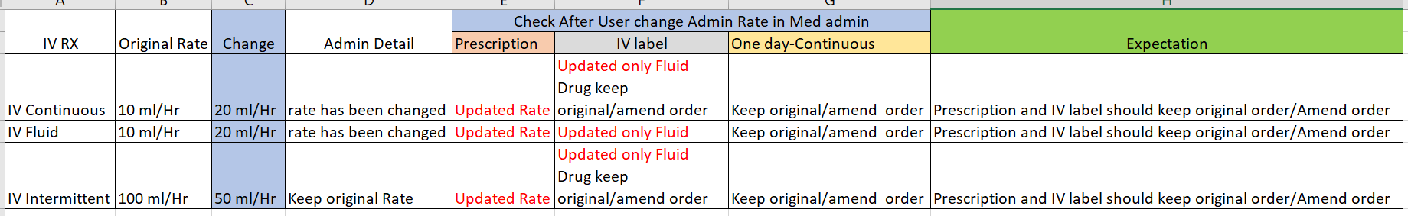

Please see the sample original order and amend order from of IV Continuous

1.IV Continuous

Case1 original order

Place IV Continuous with rate 10 ml/Hr , infusion over 10Hr

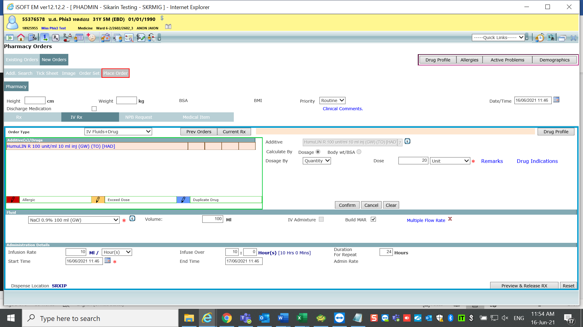

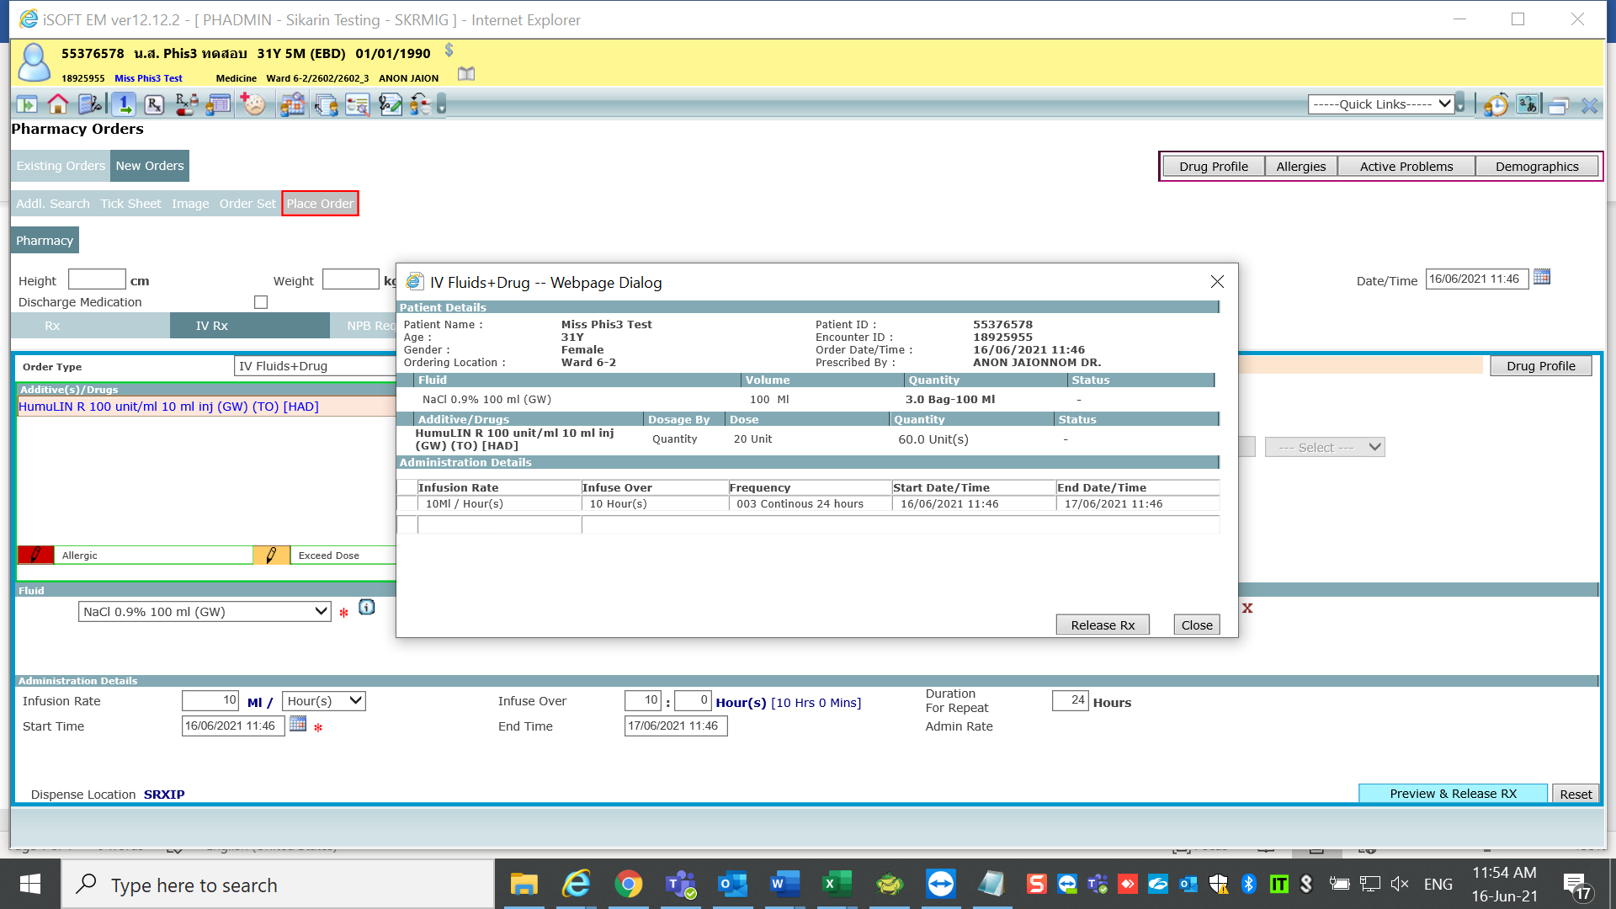

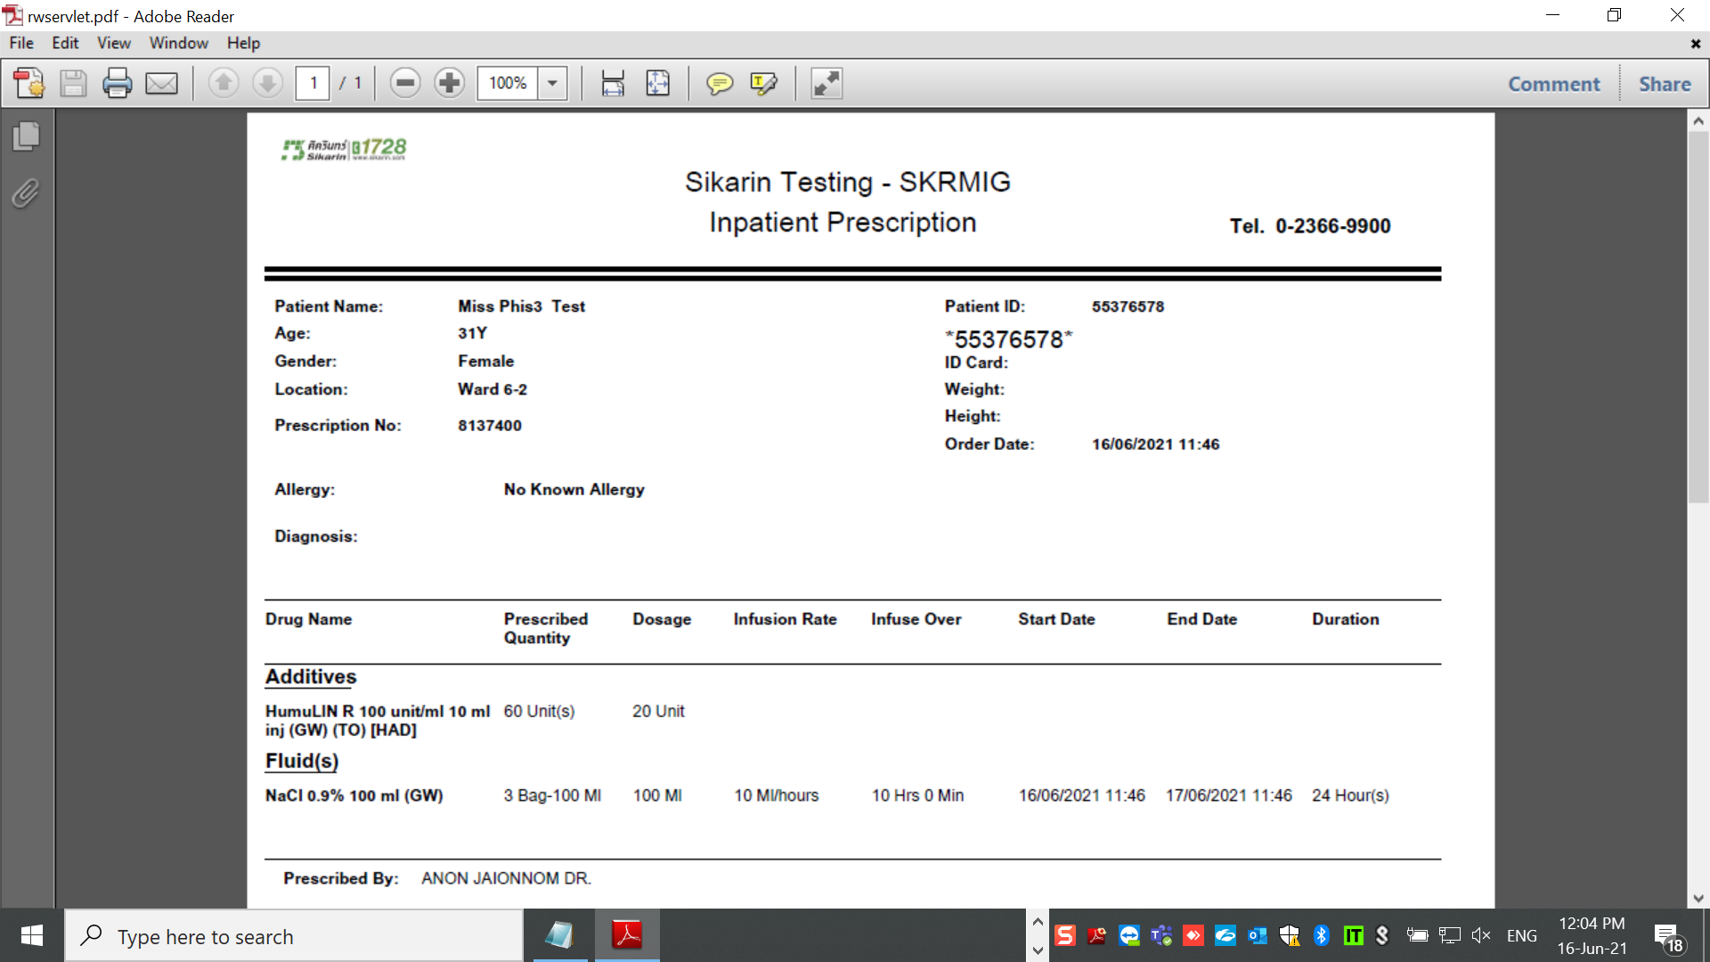

Ok

One day displayed rate from original prescription correctly

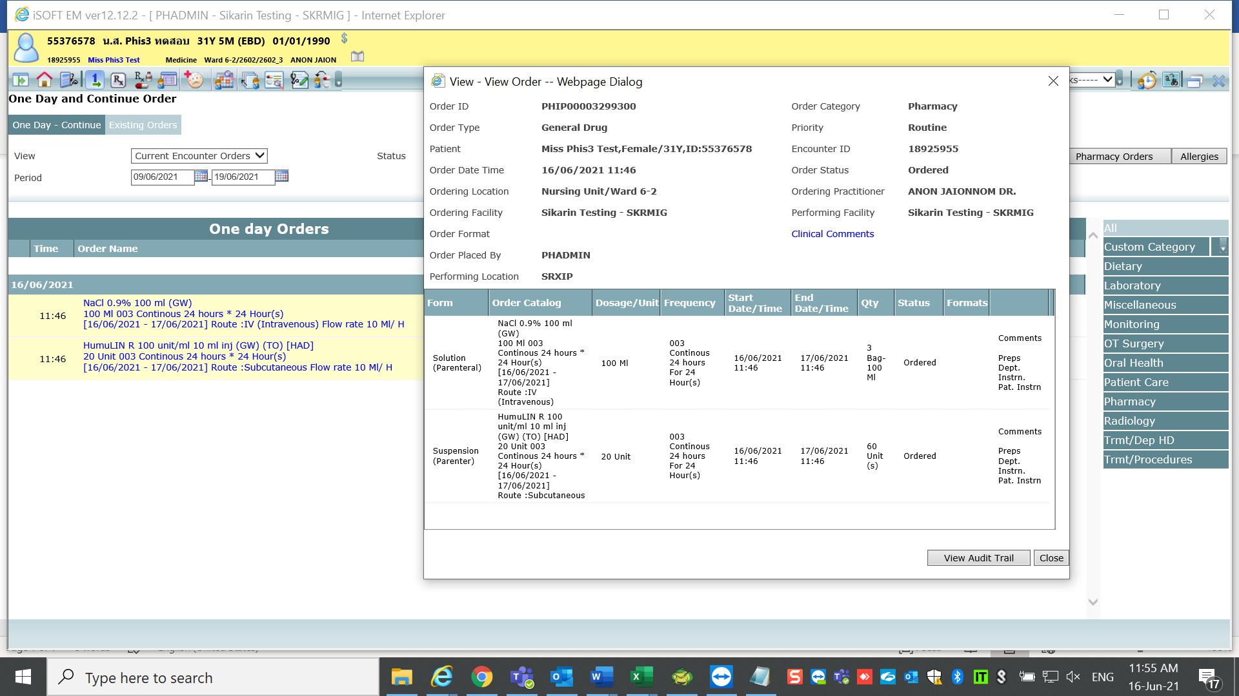

Dispense medication

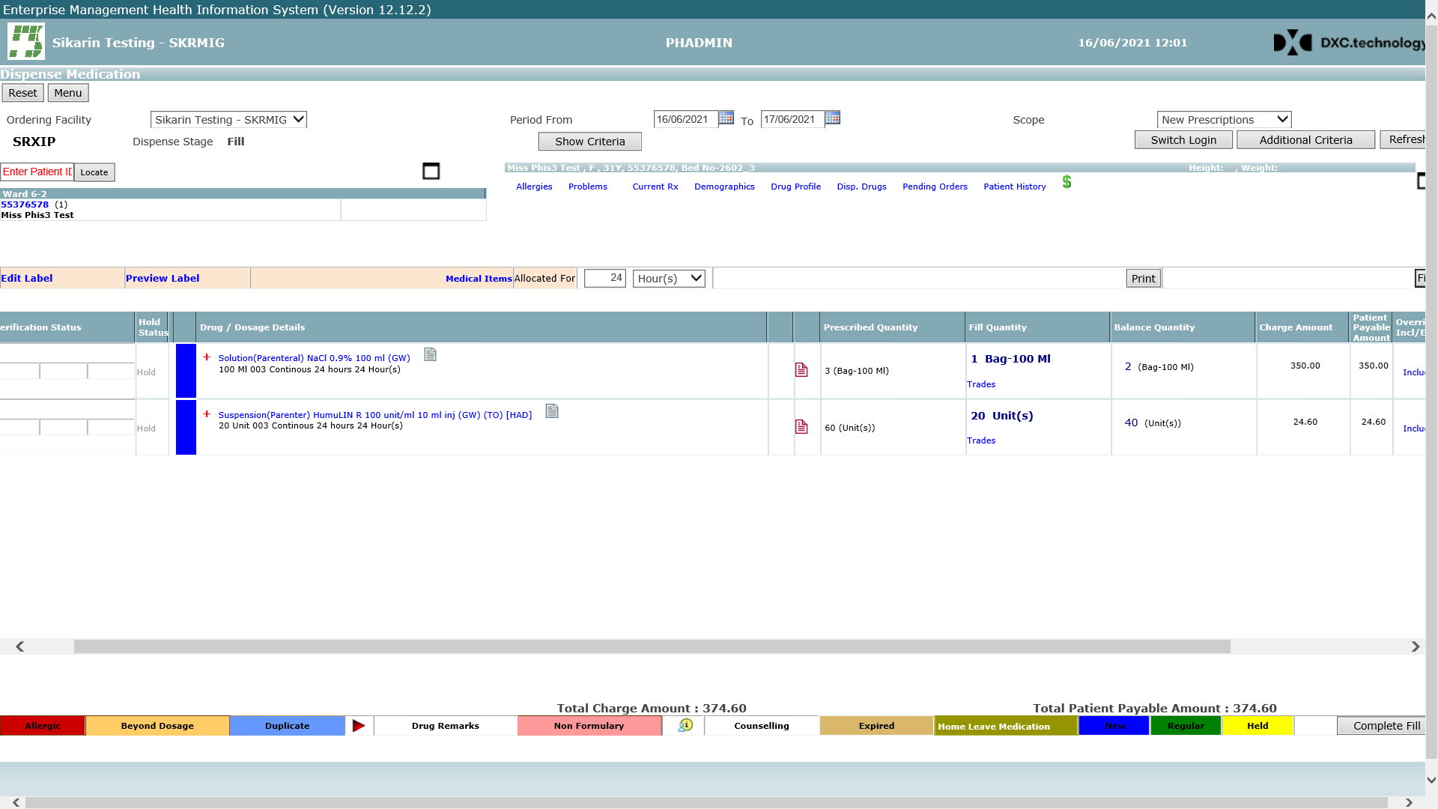

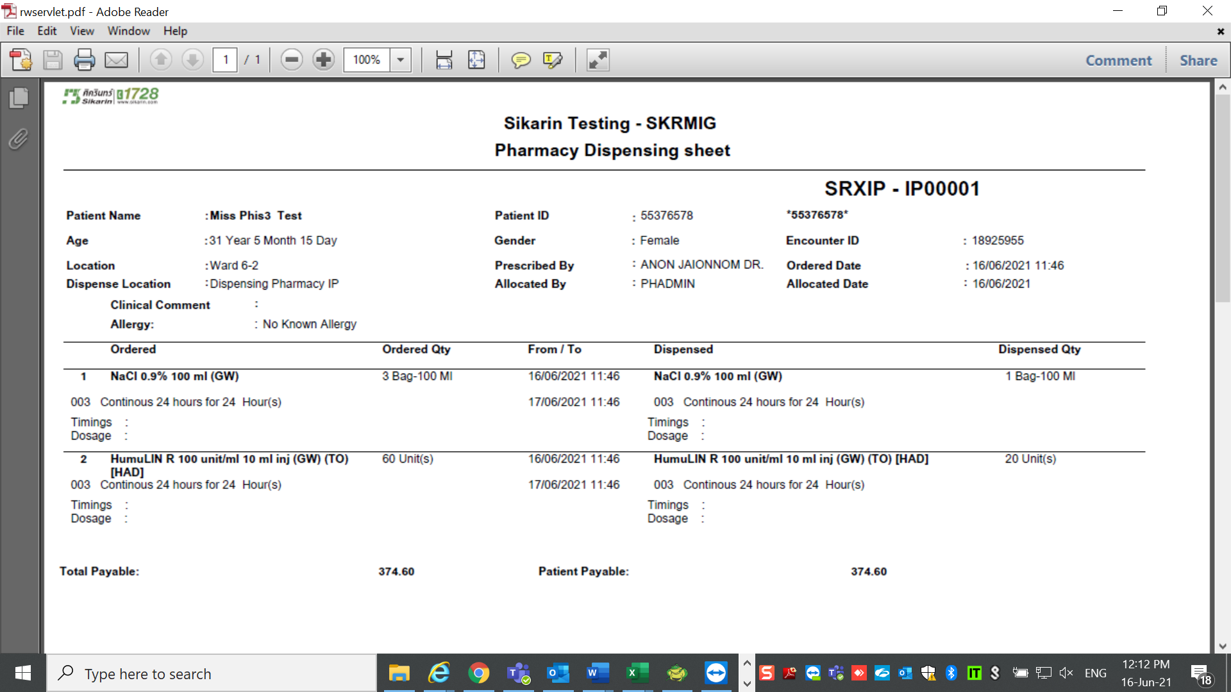

Before change admin rate , it displayed rate & infusion over as per prescription correctly.

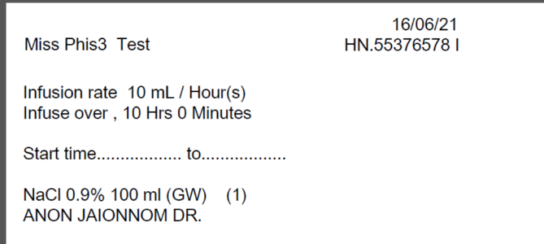 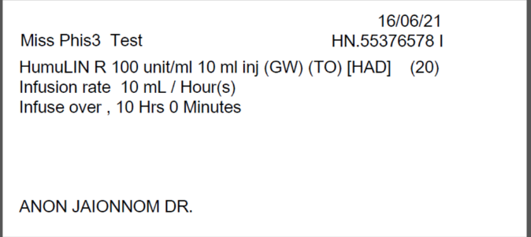

Admin Medication

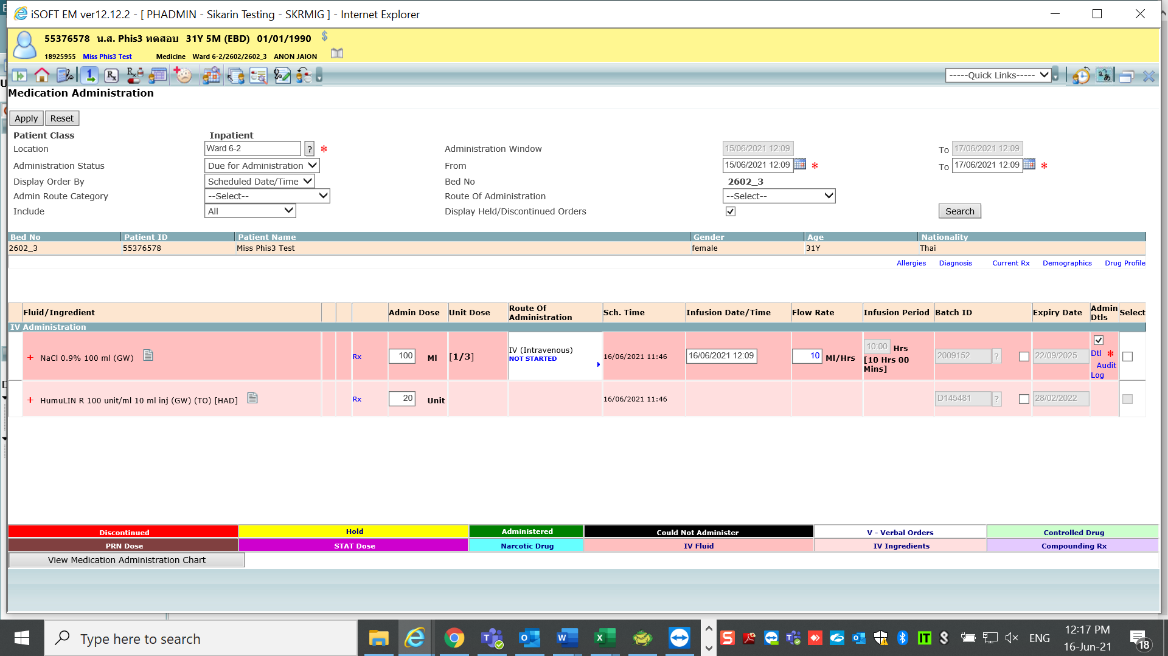

User change rate from 10ml/Hr to 20ml/Hr

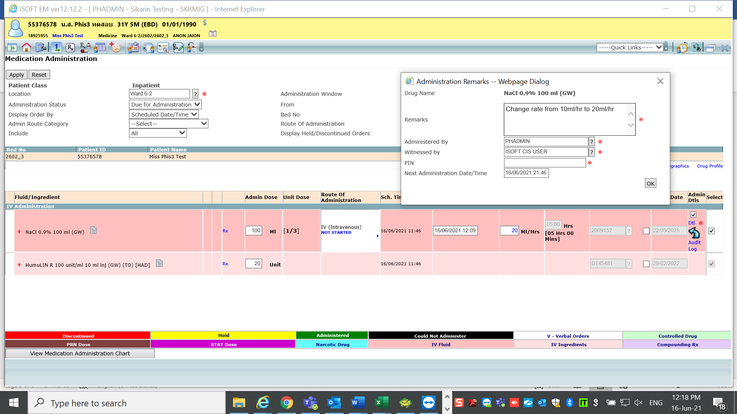

After Apply—Med admin updated to new rate 20ml/Hr

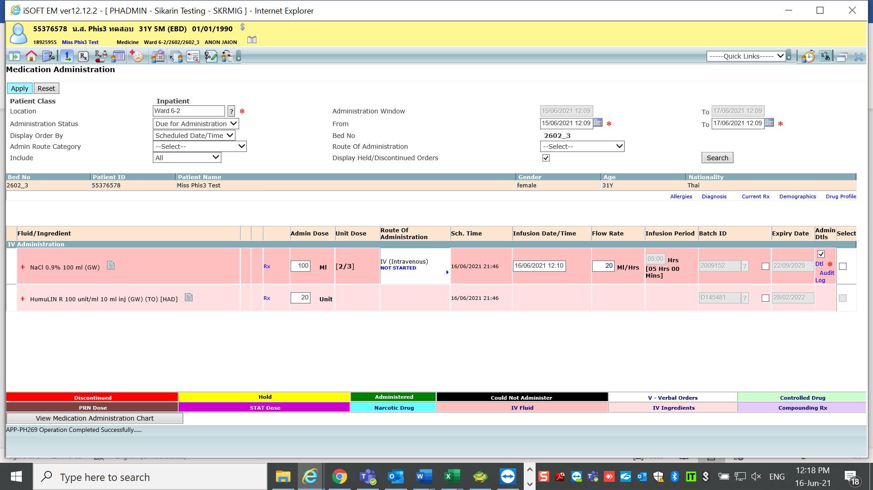

Recheck report after admin change rate

1.Prescription

It Updated change rate from 10ml/hr to 20ml/hr—It should keep original order or amend order

It should not considering Administration recorded.

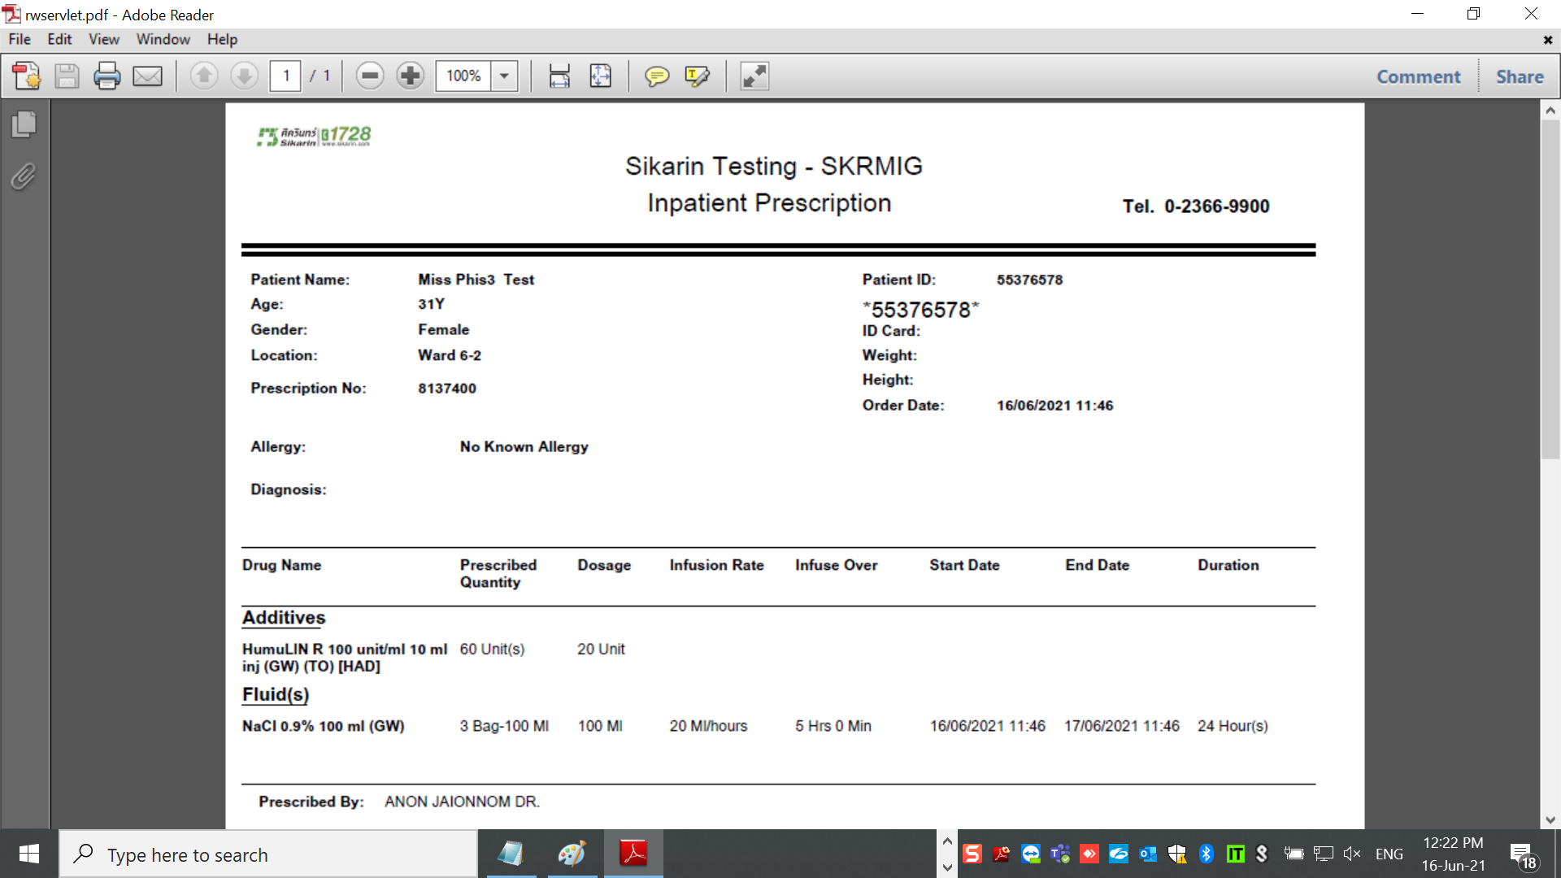

It should keep rate 10ml/hour , infusion rate 10Hr because there is no amend order.Changing rate in medication administration is depend on situation then system should not update rate in prescription.

2. IV Label

Fluid updated to new rate but Drug is still display original rate?

Both Fluid and drug should keep rate and Infusion over as same as original/amend order

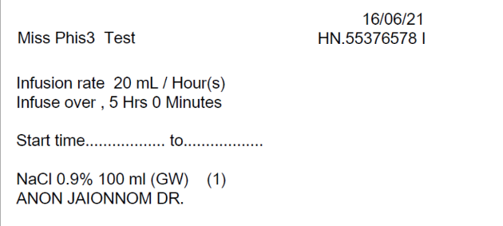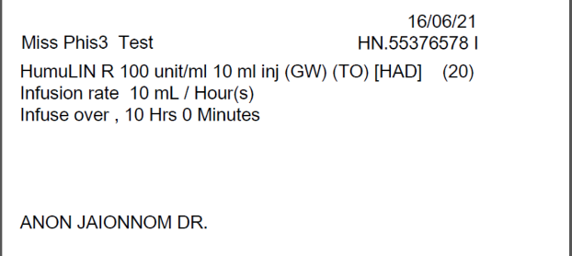

3.One day still display rate base on Original order correcly

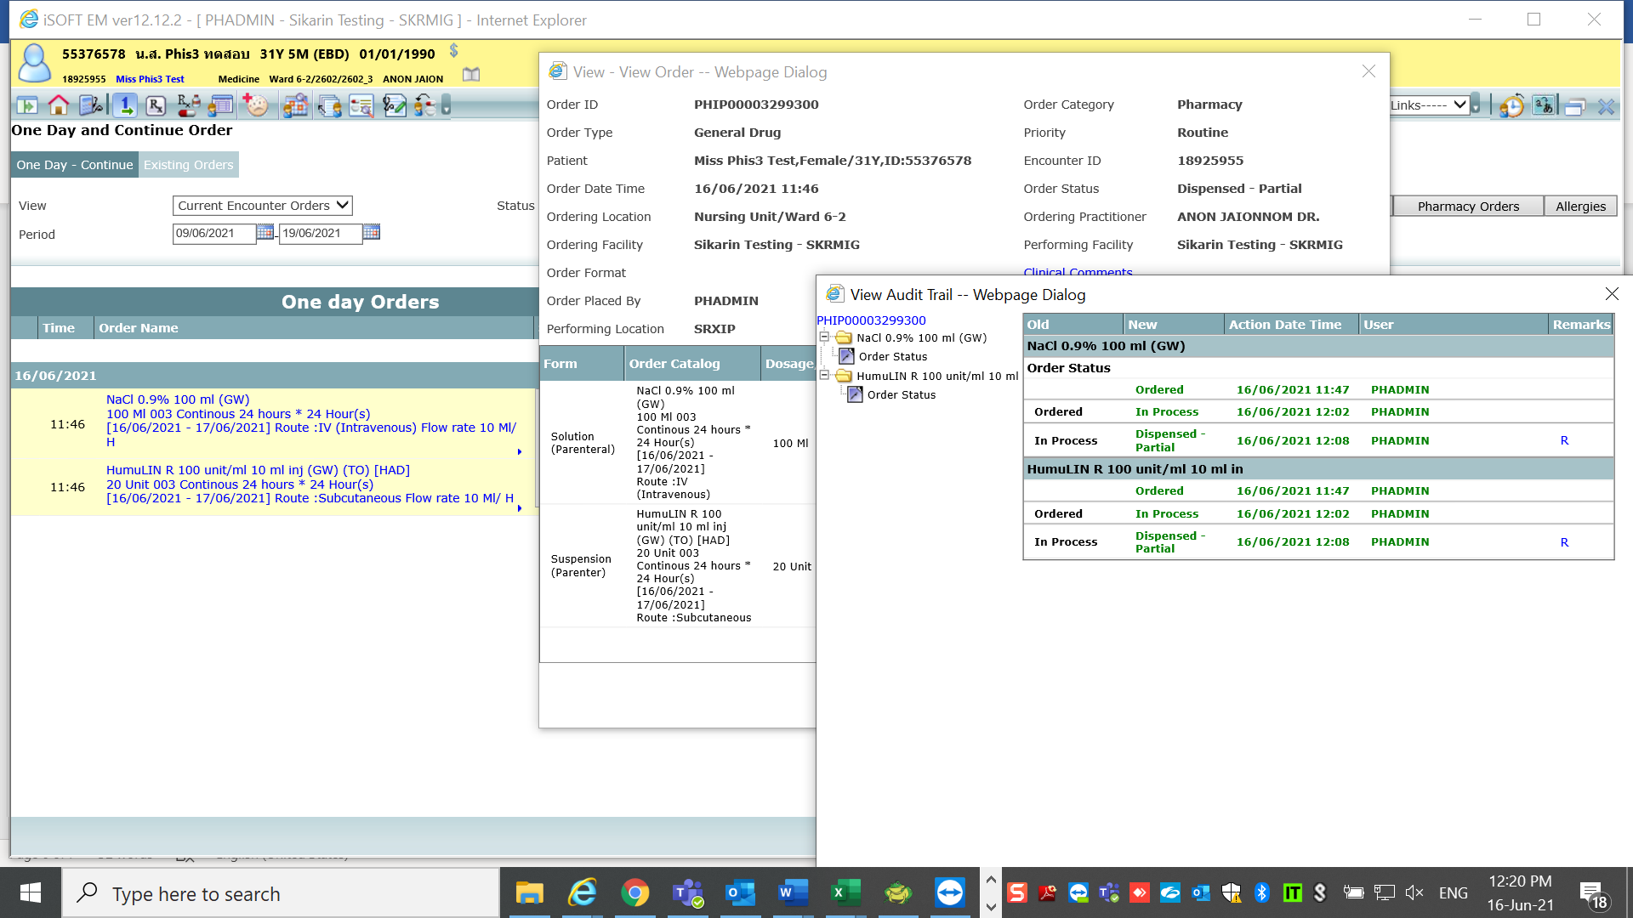

Case2 Amend order

Original order

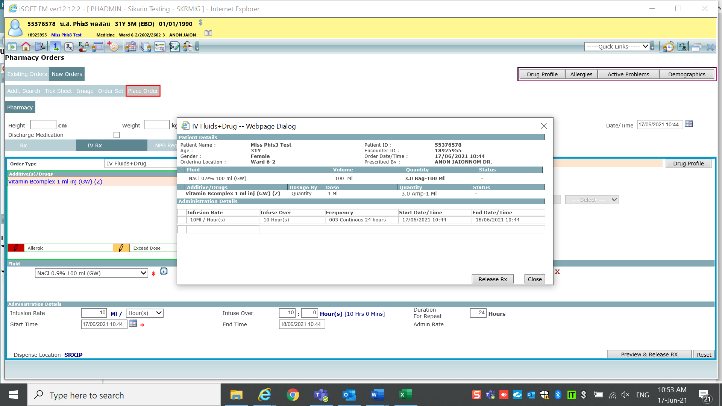

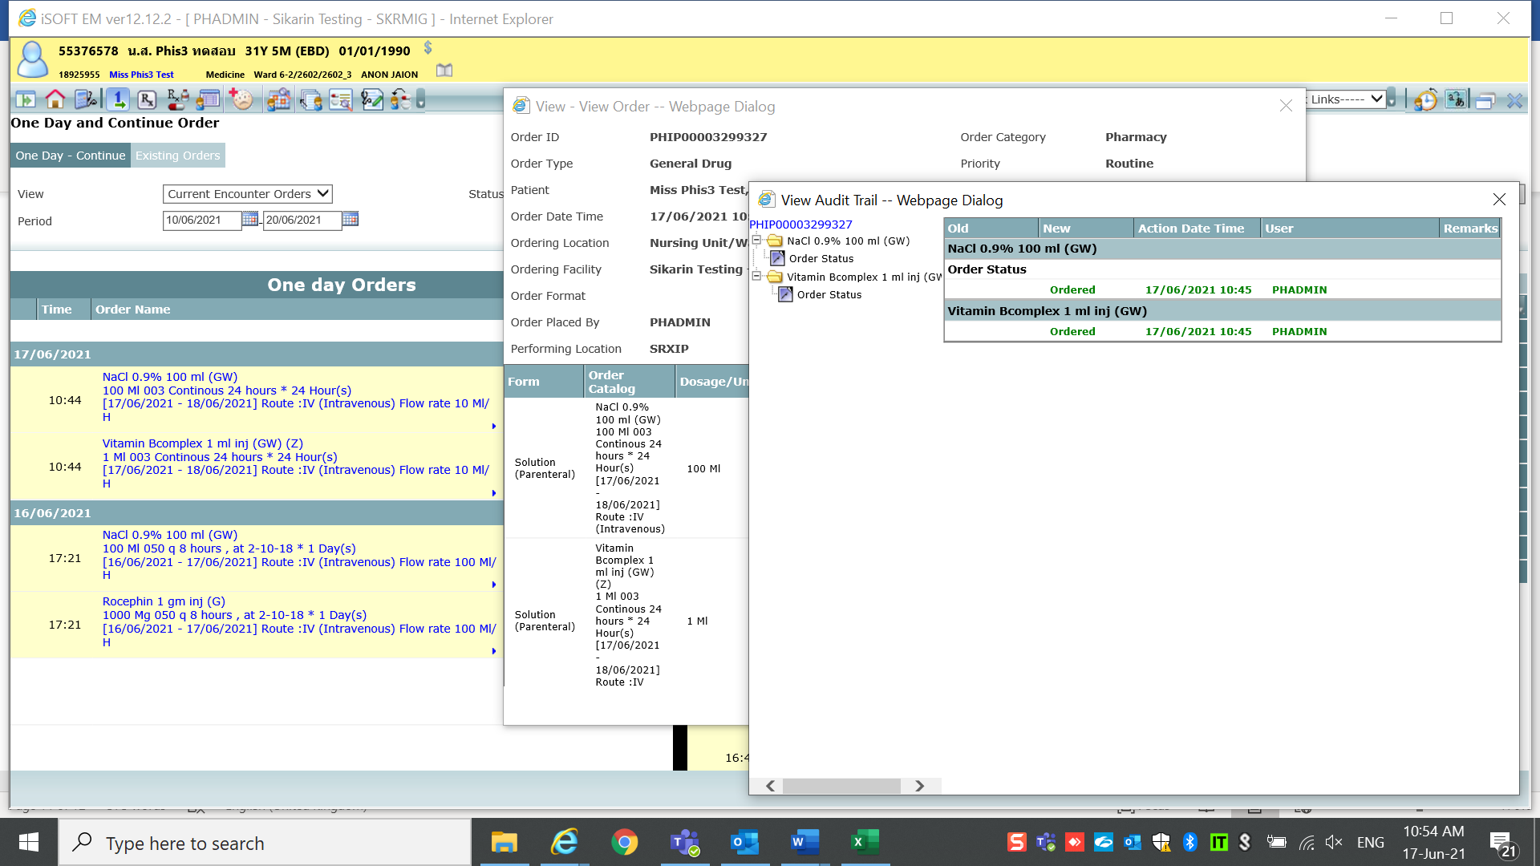

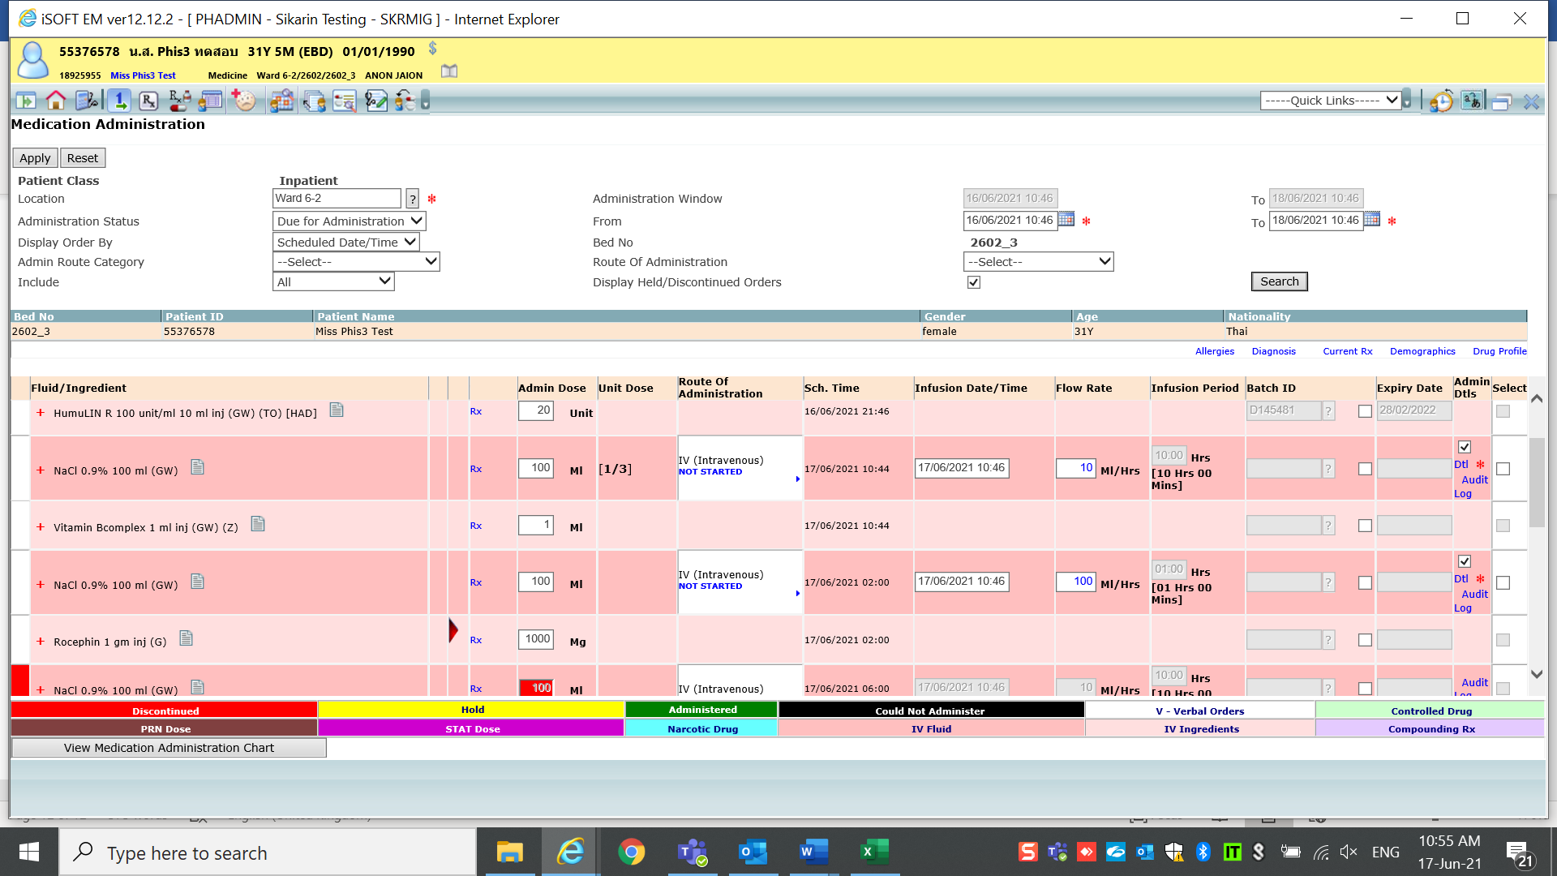

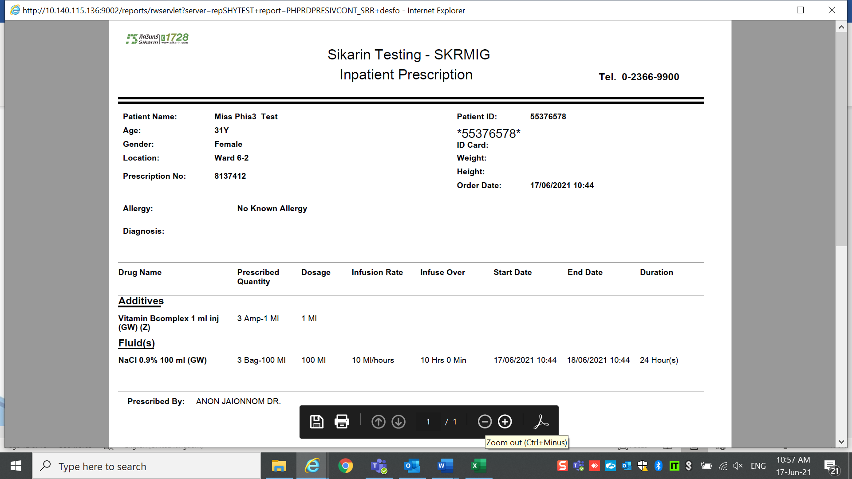

Then amend order

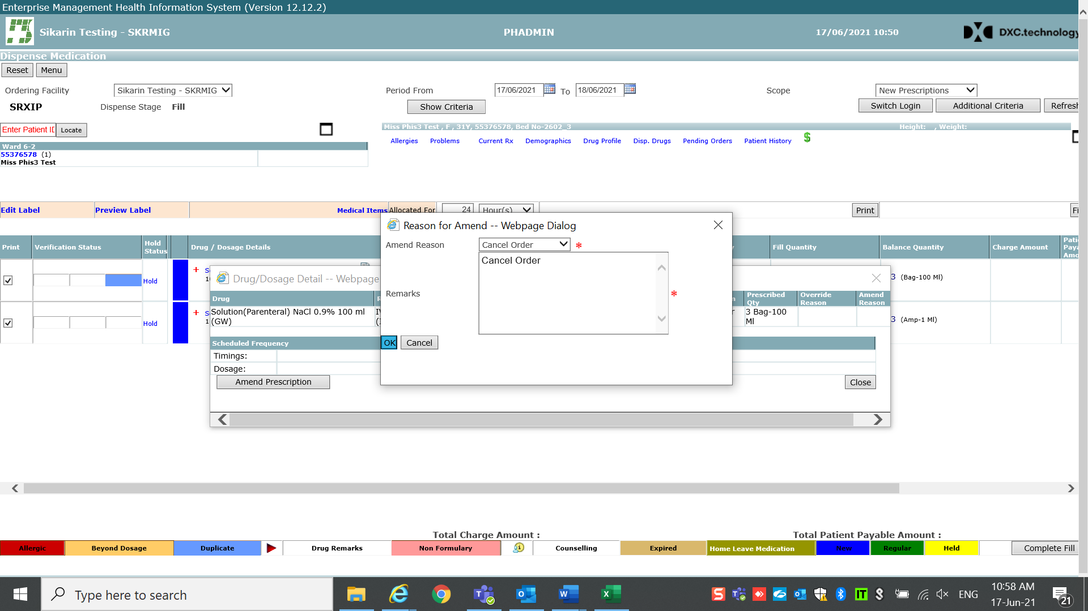

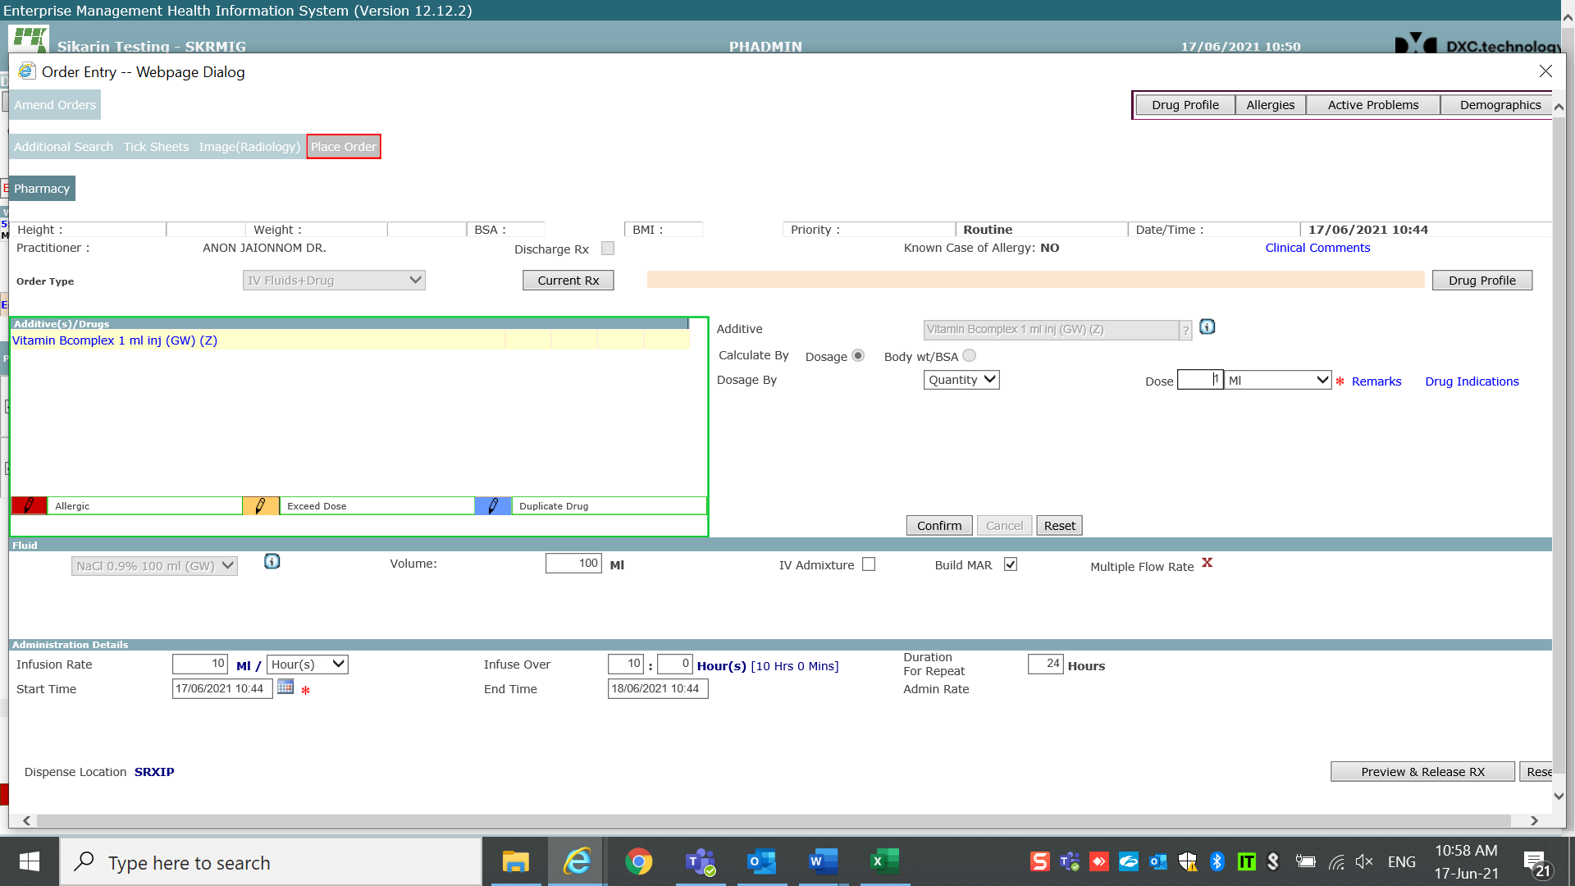

Change rate

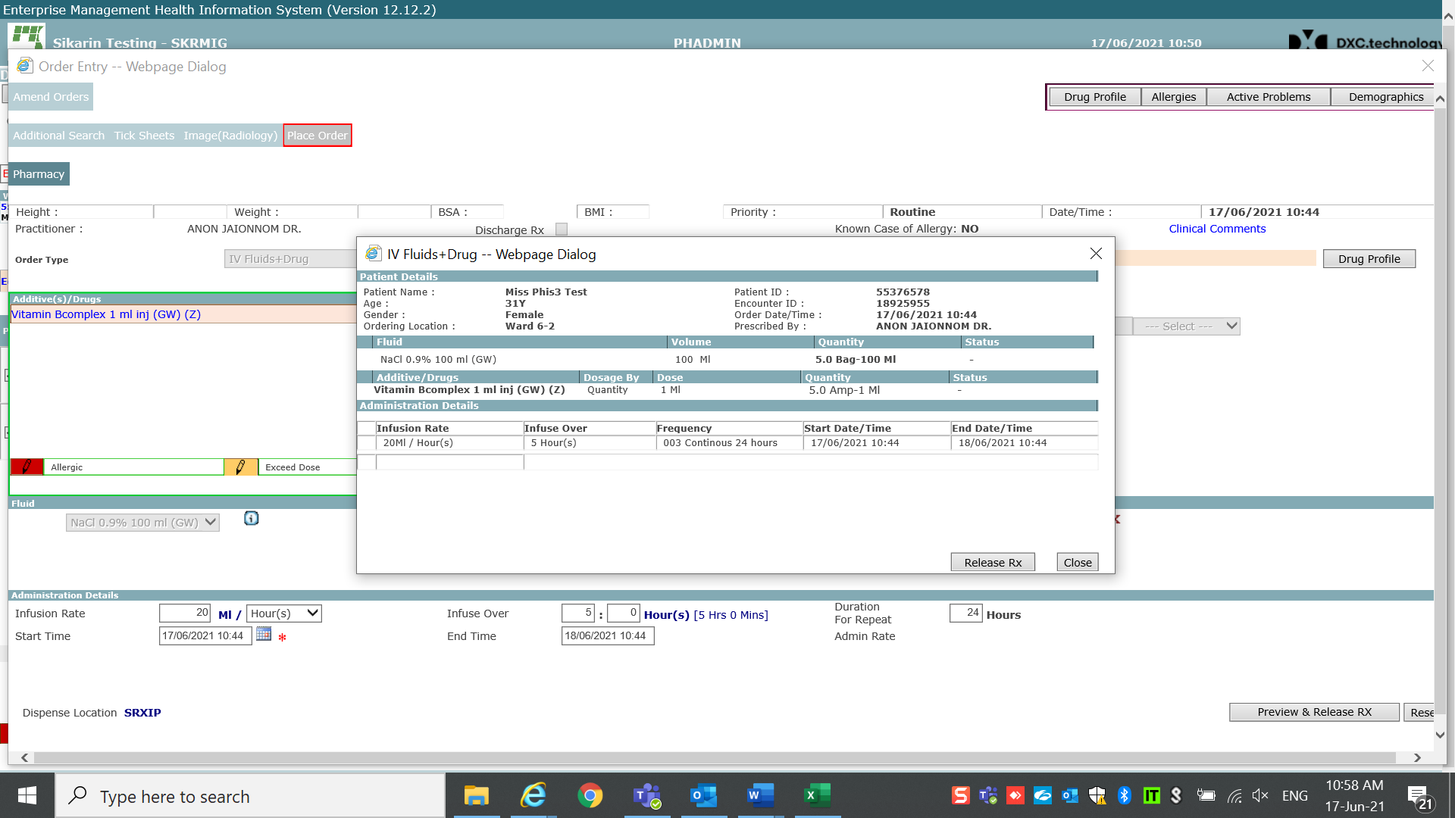

Prescription updated rate and infusion over as per amend correctly

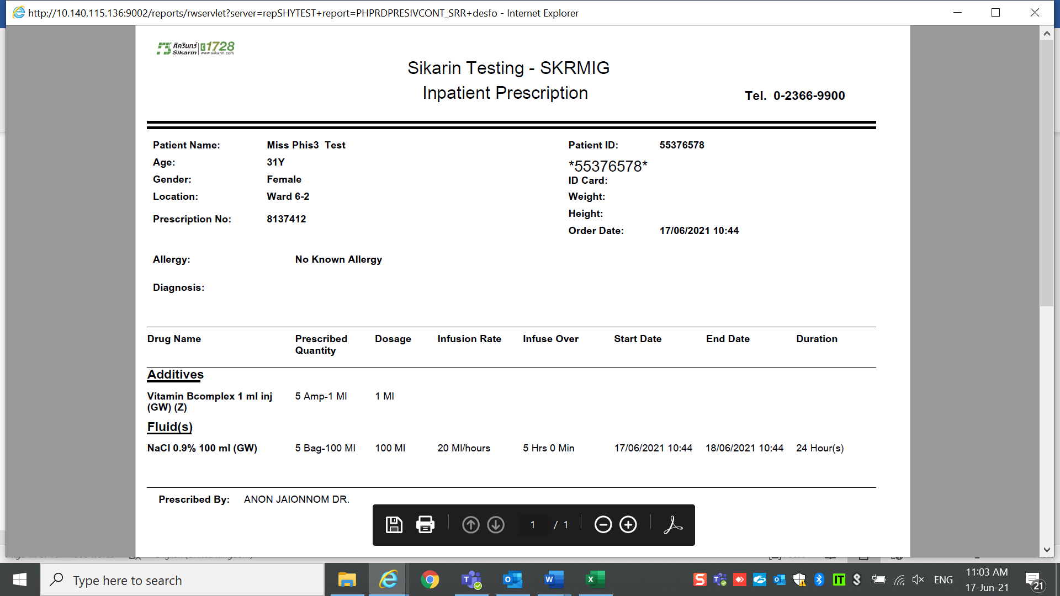

One day display rate from amend order correctly

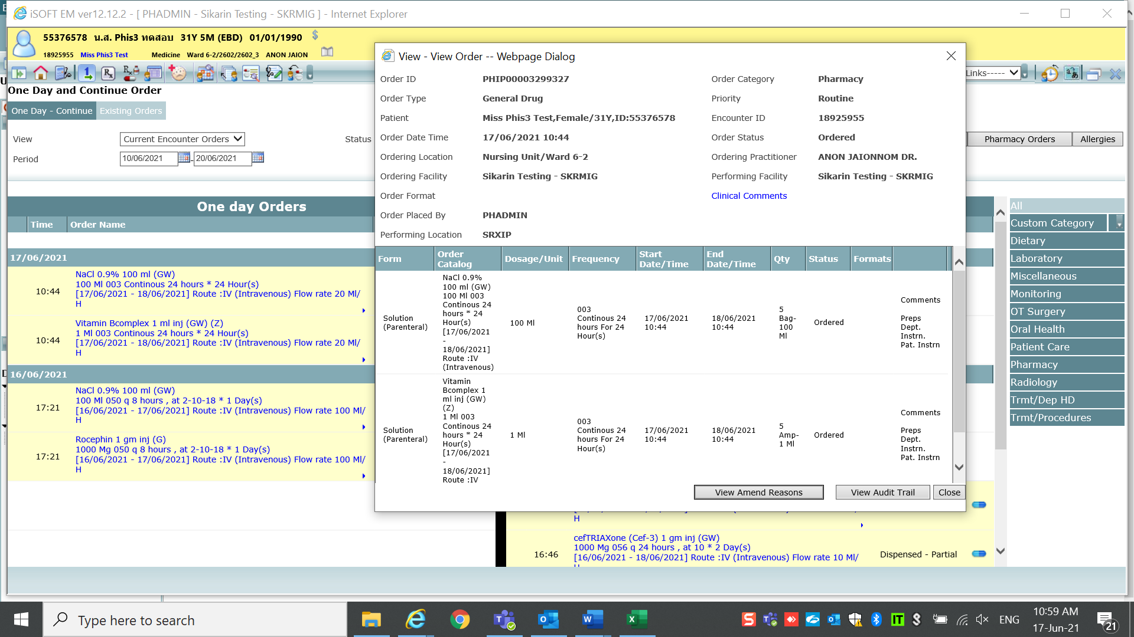

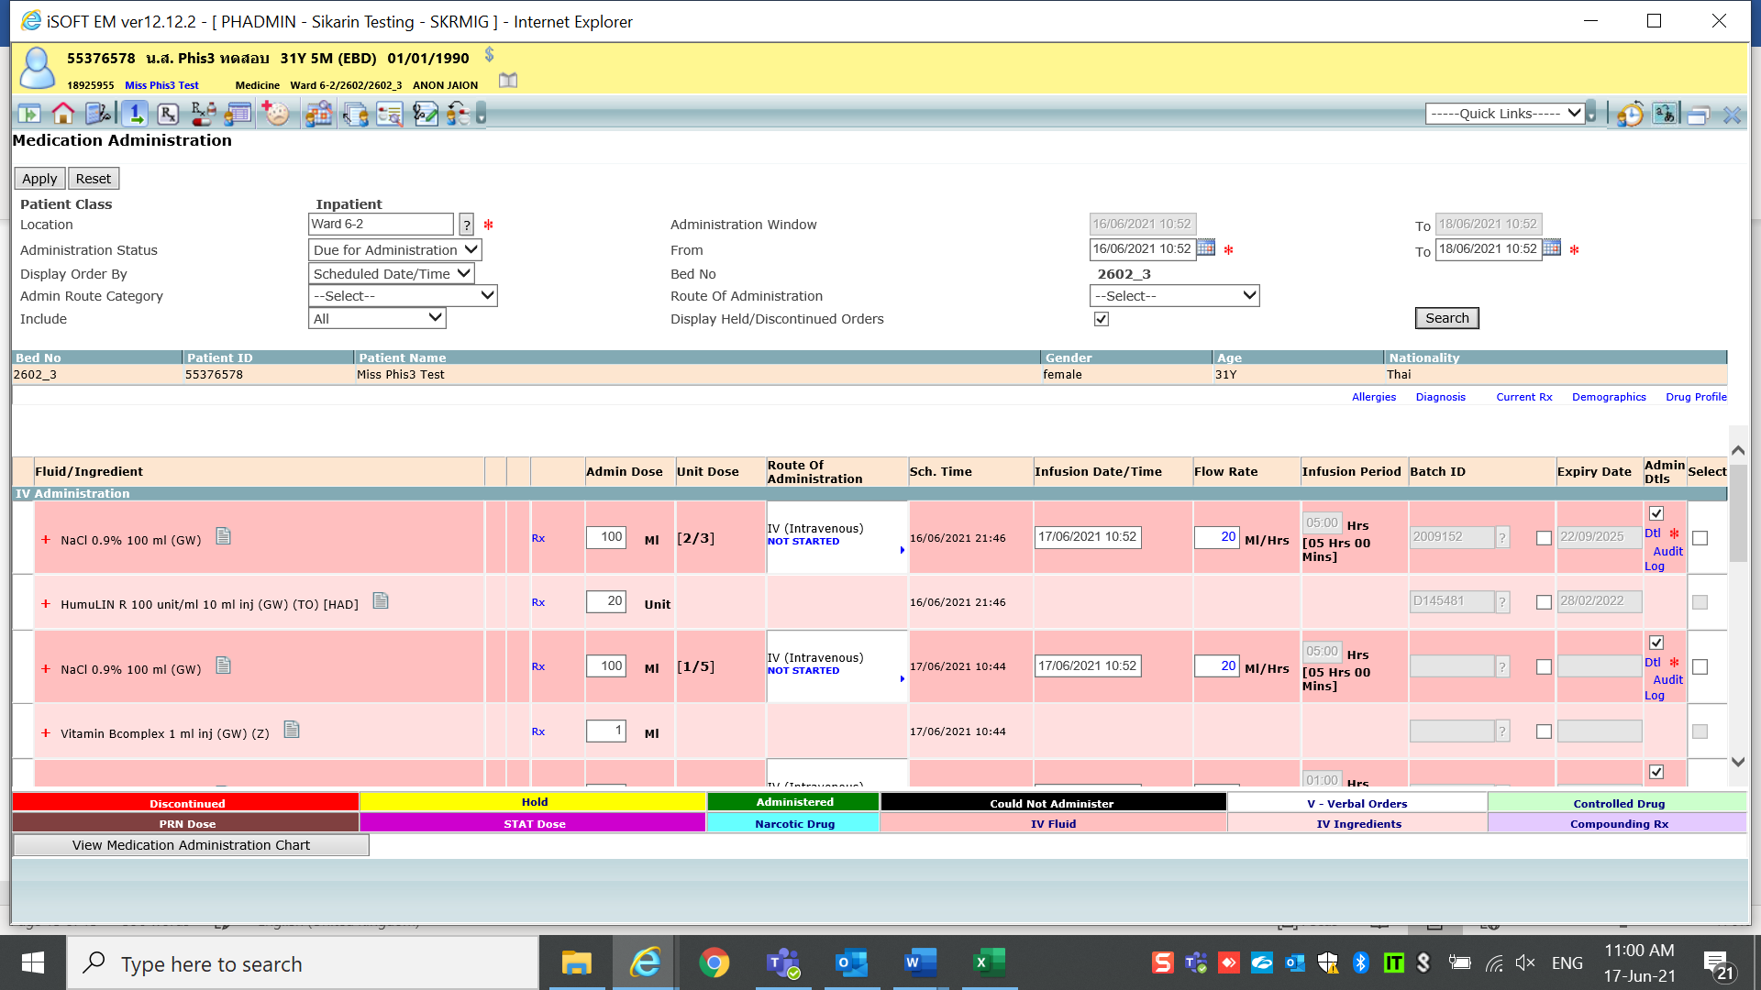

Rate update as same as amend order -ok

then user change rate to admin

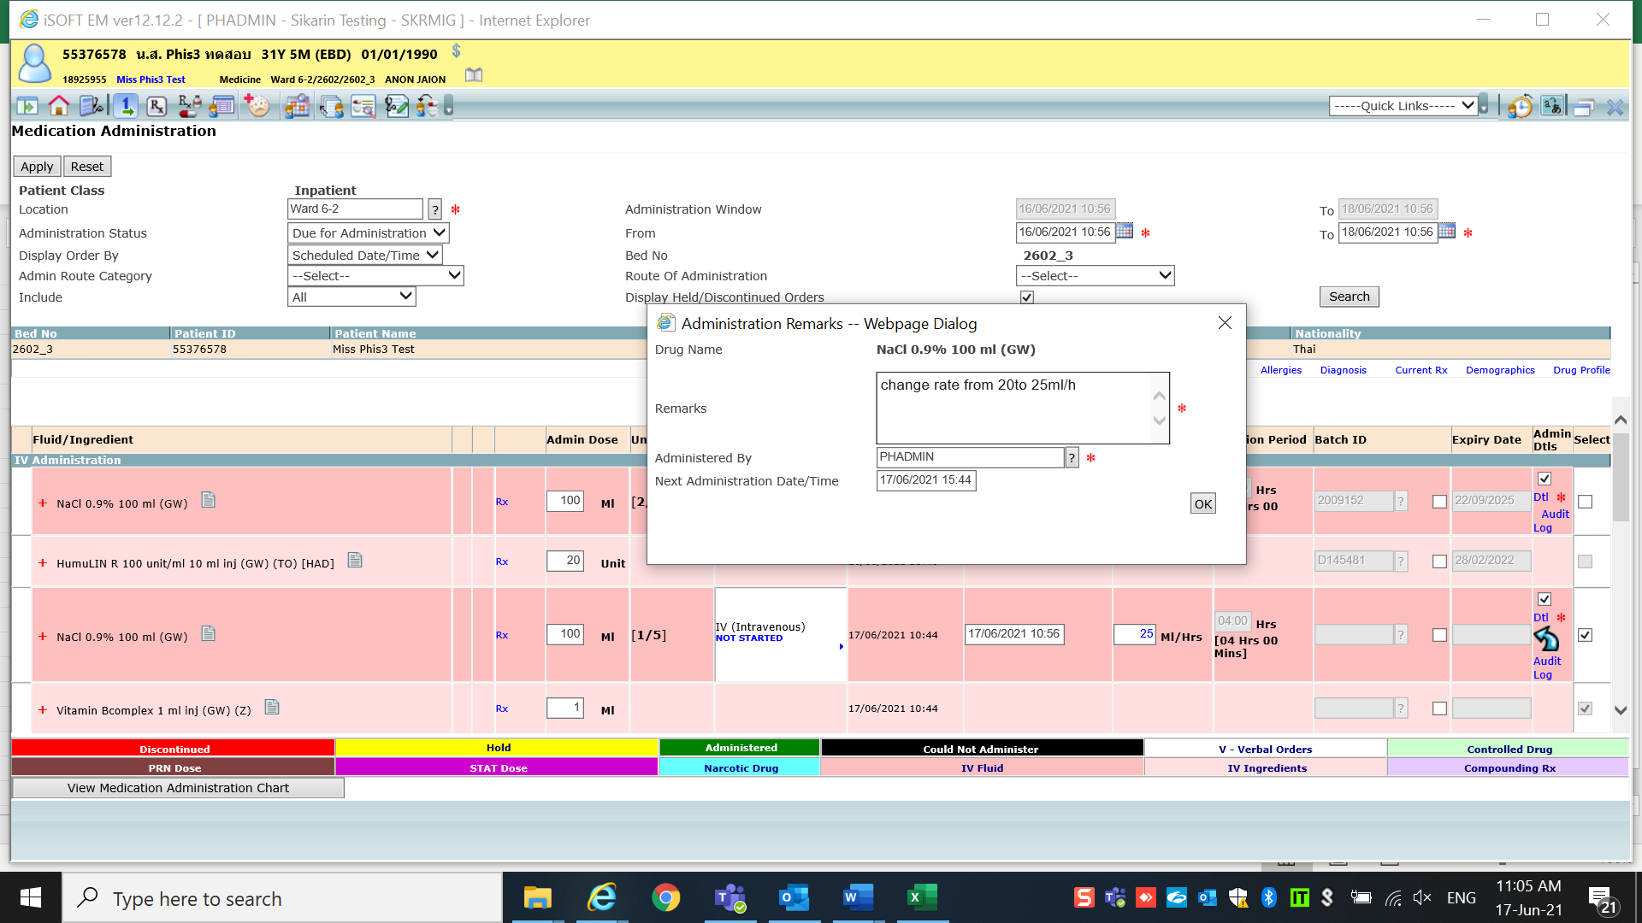

Then apply

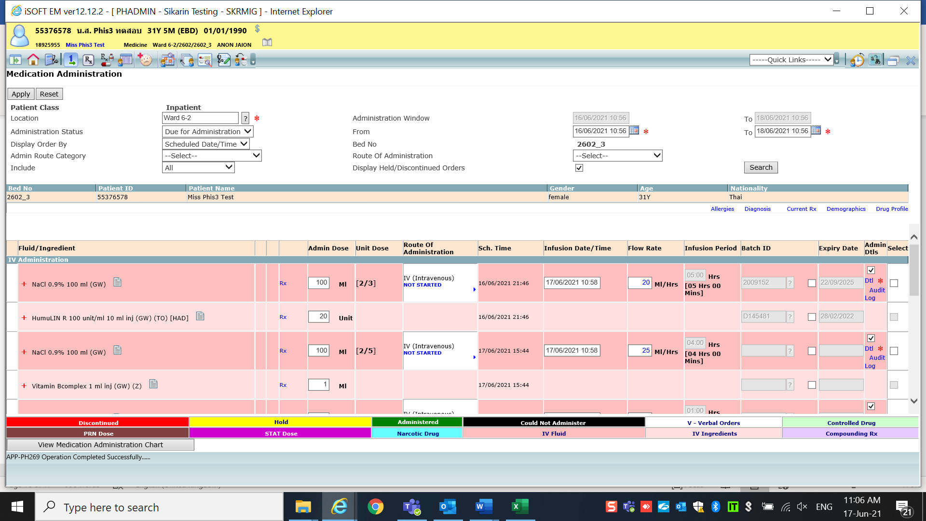

Re Check

One day display flow rate correctly

but prescription and IV label updated to new rate from Med admin which is wrong

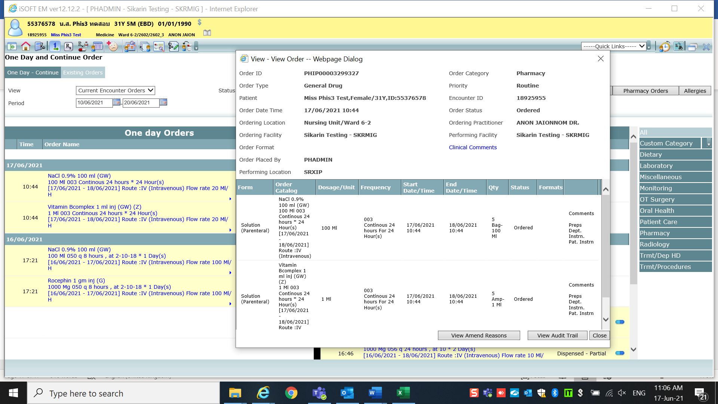

Prescription after change rate in med admin

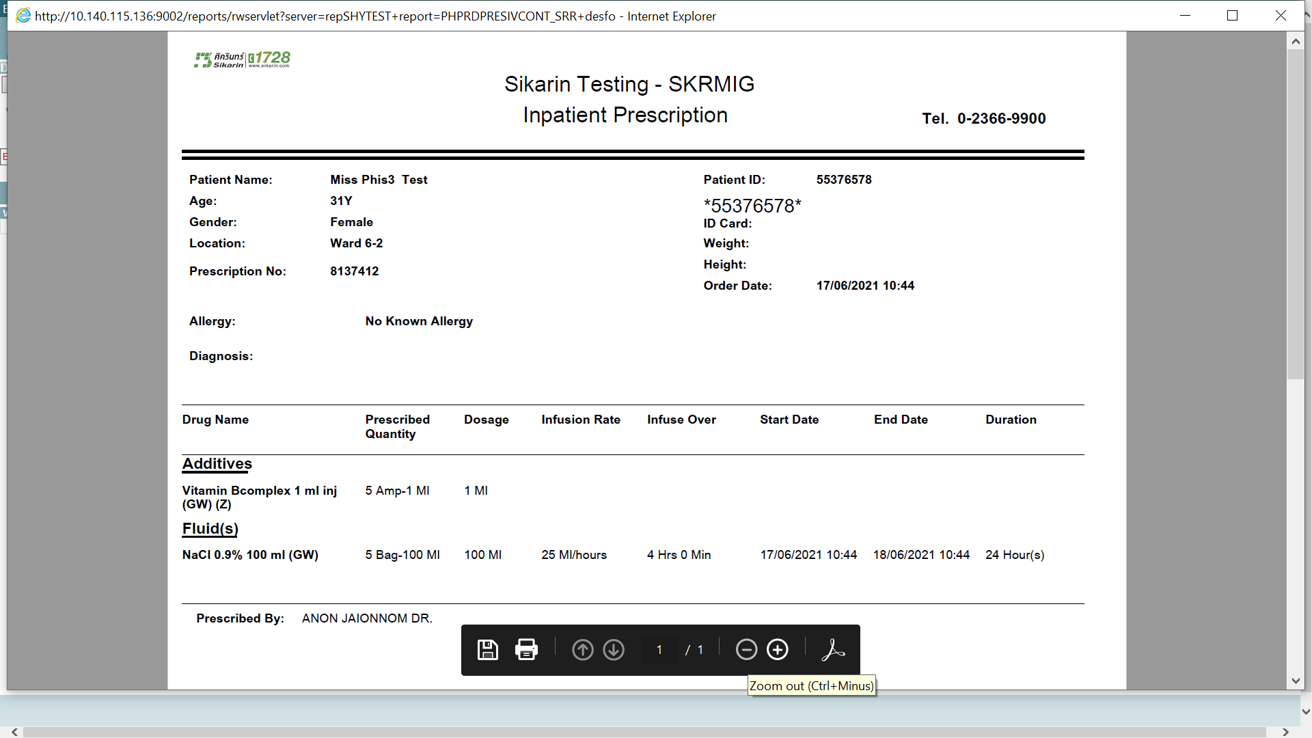

It should display 20ml/hr infusion over 5Hr as per last amend order

IV label after change rate in med admin

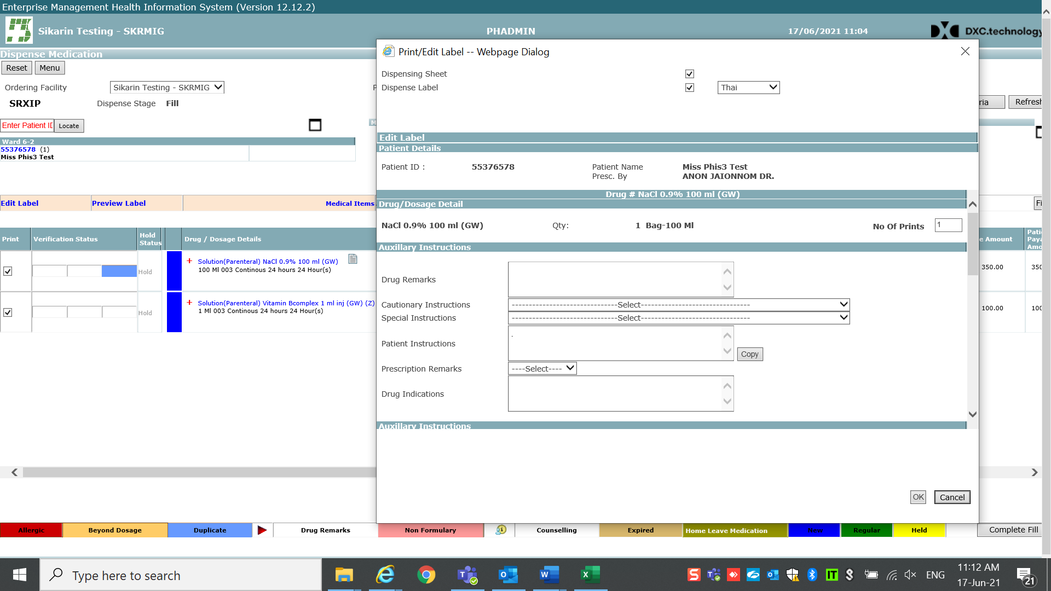

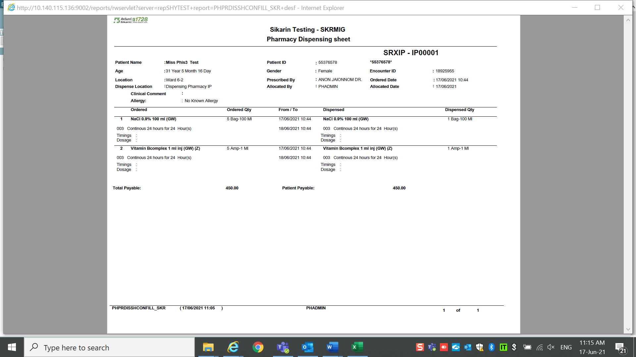

Fluid Label should keep rate and infusion over as per amend order (It should be from med admin)

Drug display rate correctly

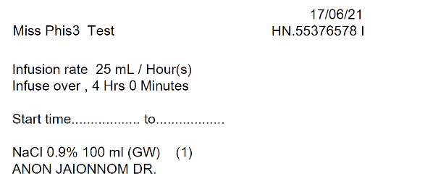 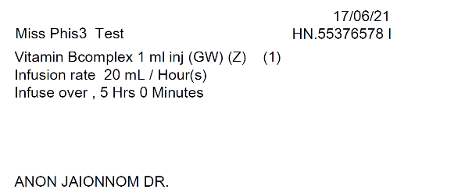

Drug is correct

Fluid is wrong

2.IV Fluid

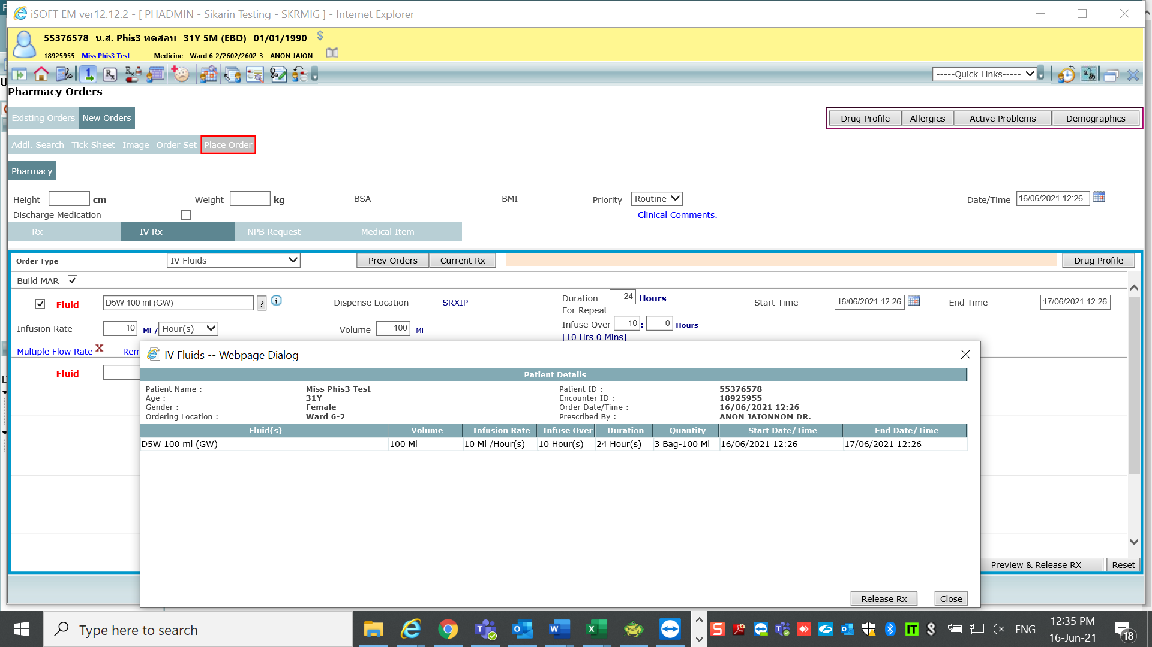

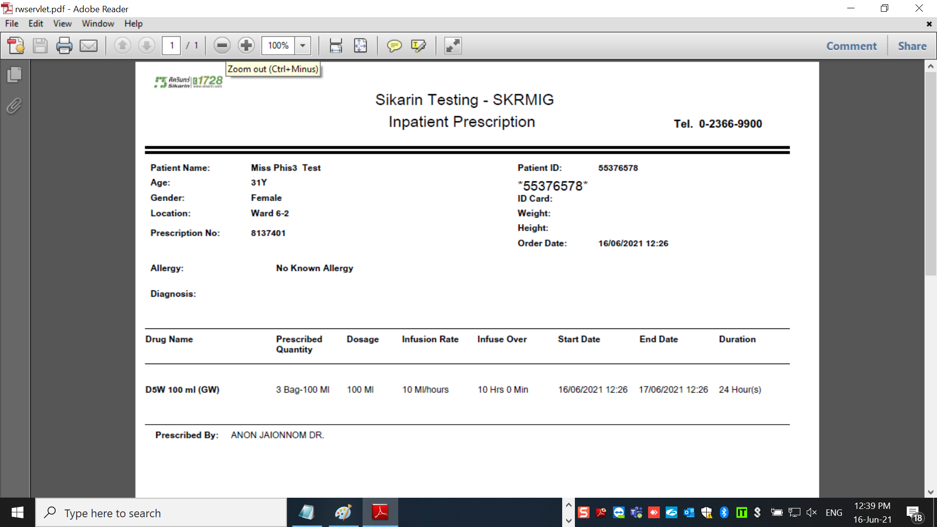

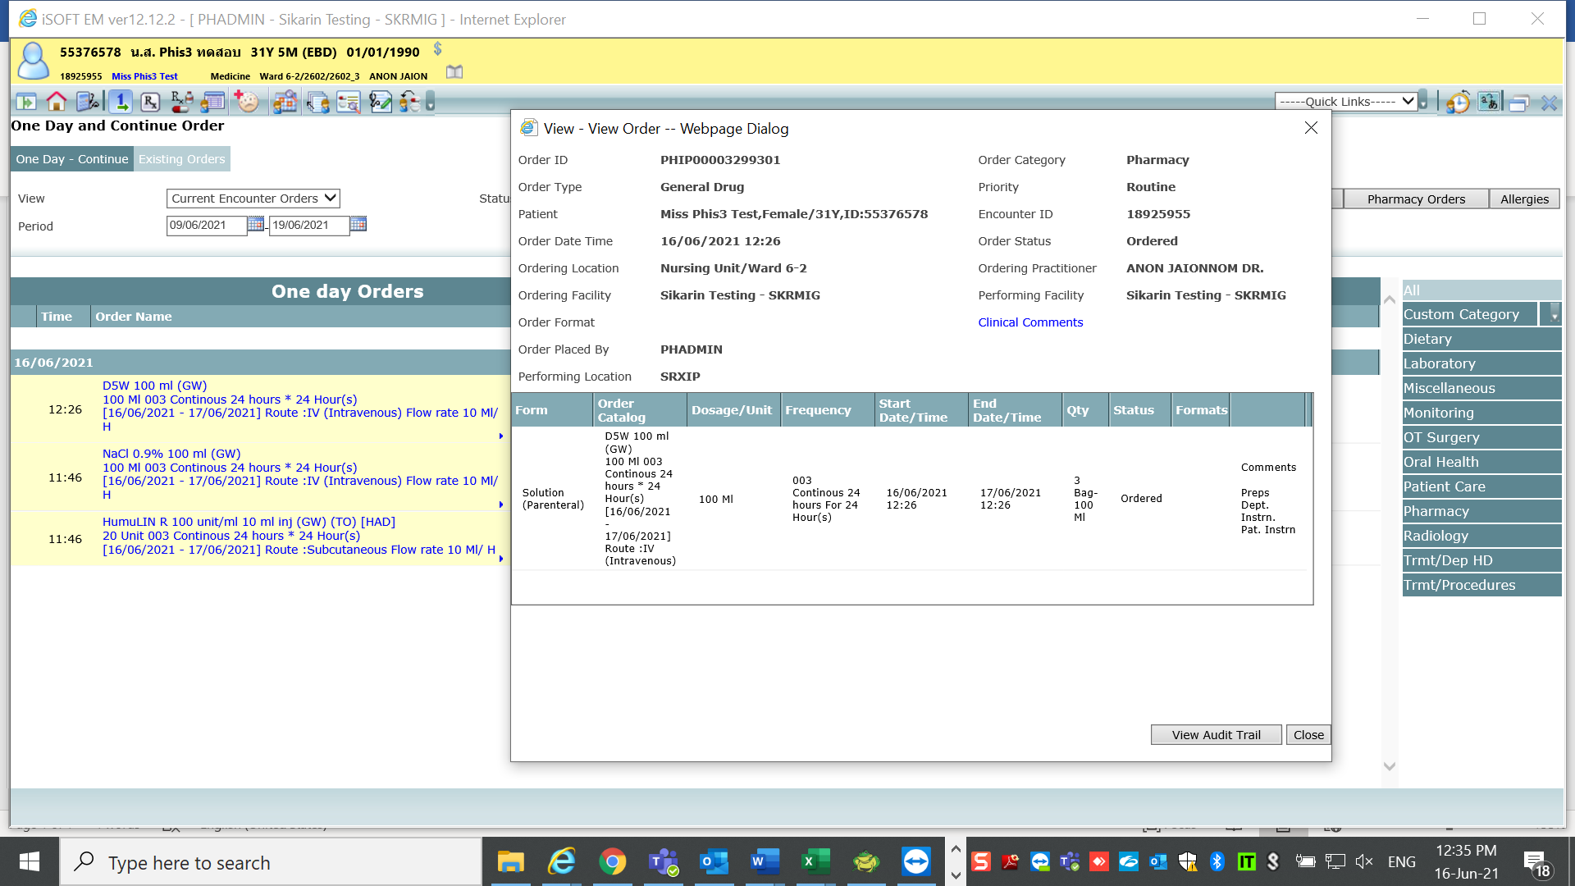

Then go to Med admin

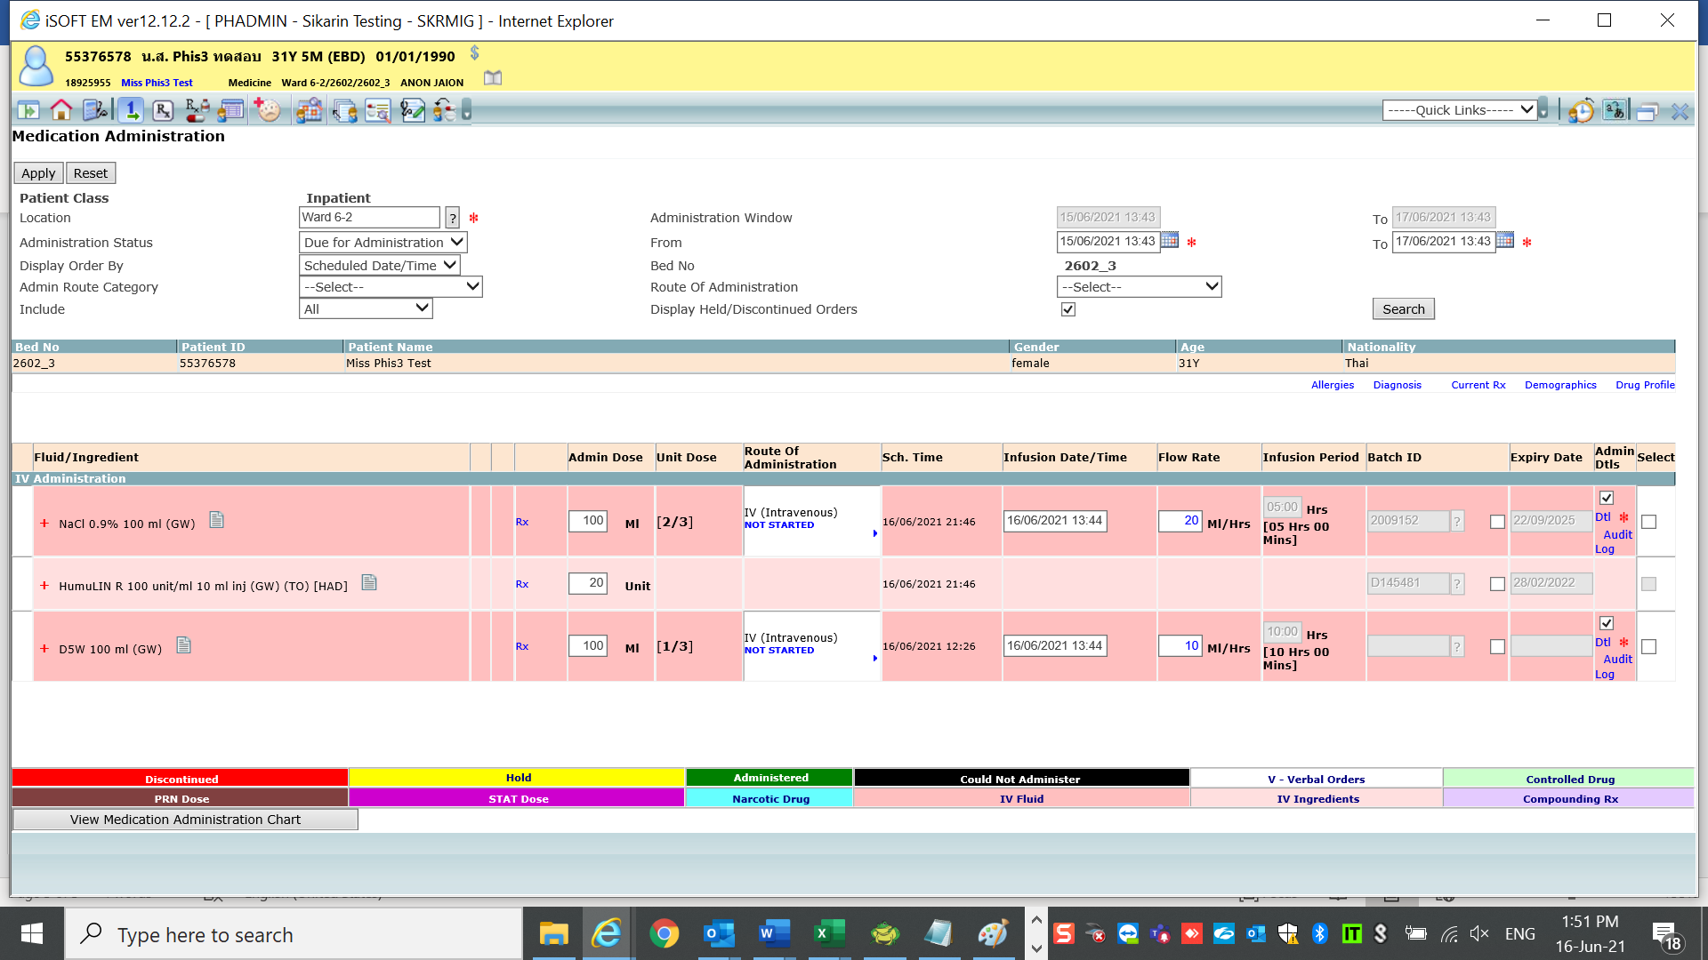

Change rate from 10 ml/hr to 20 ml/hr

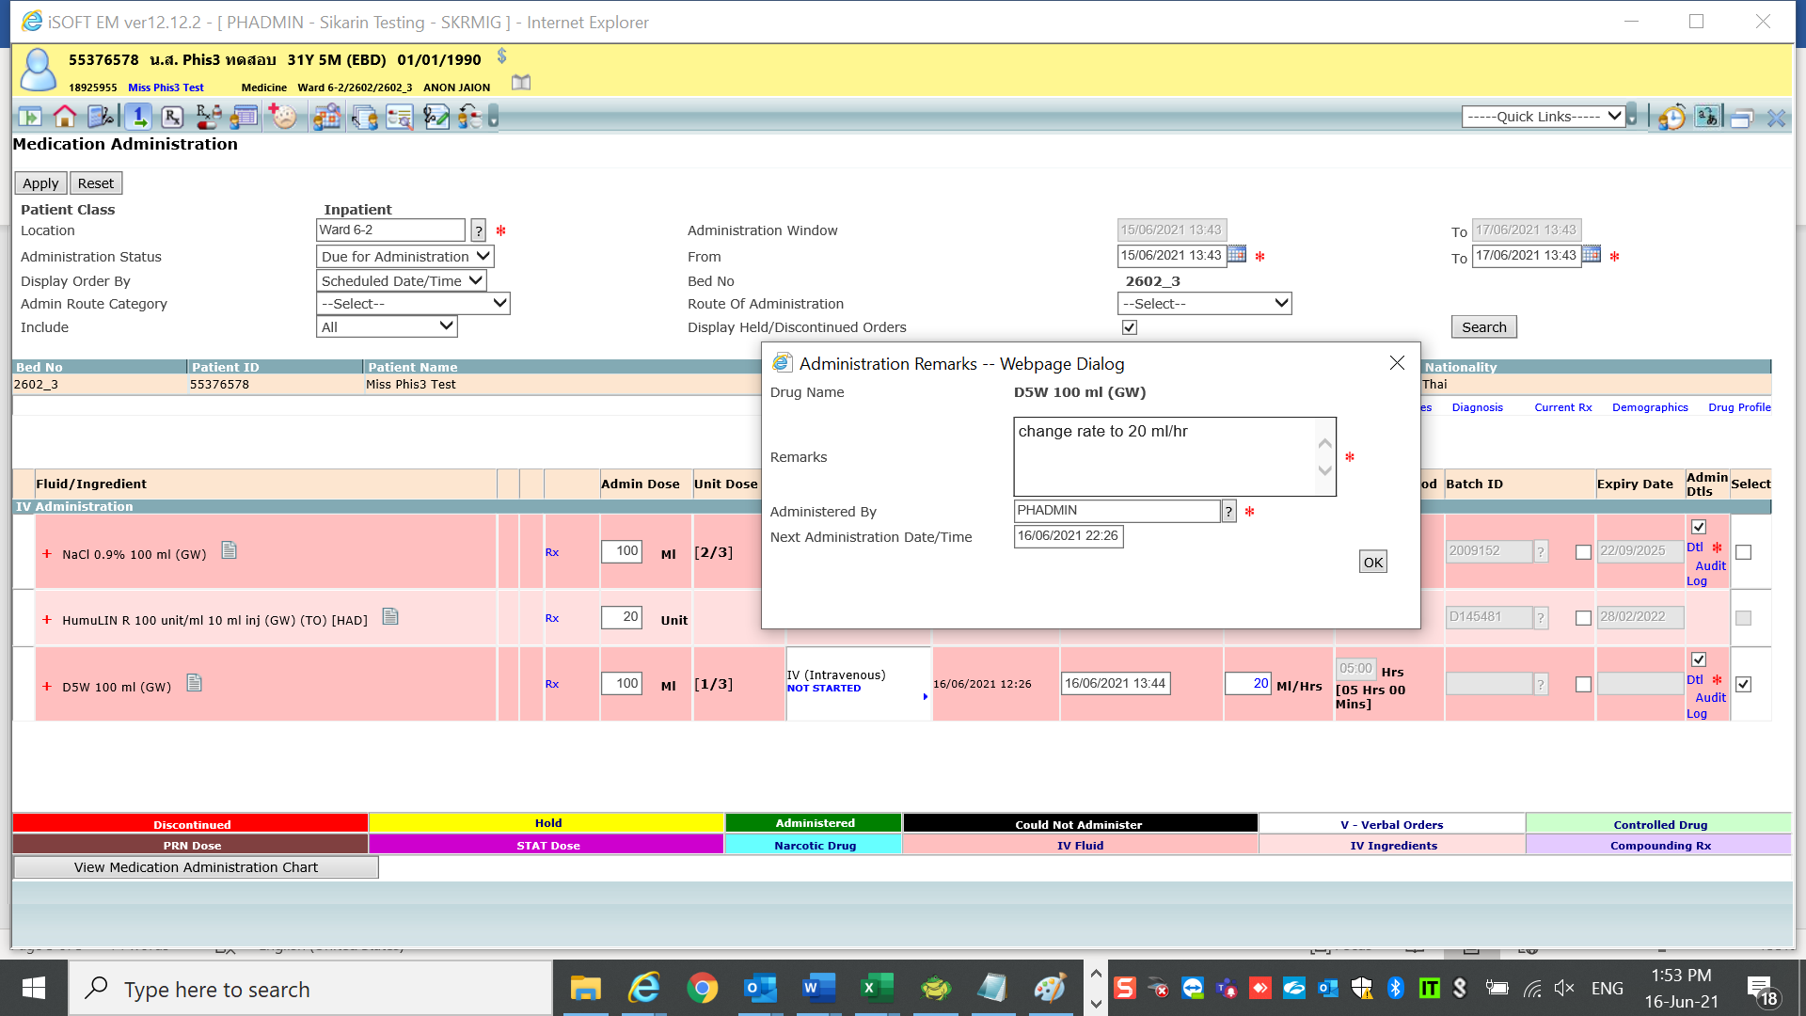

After apply

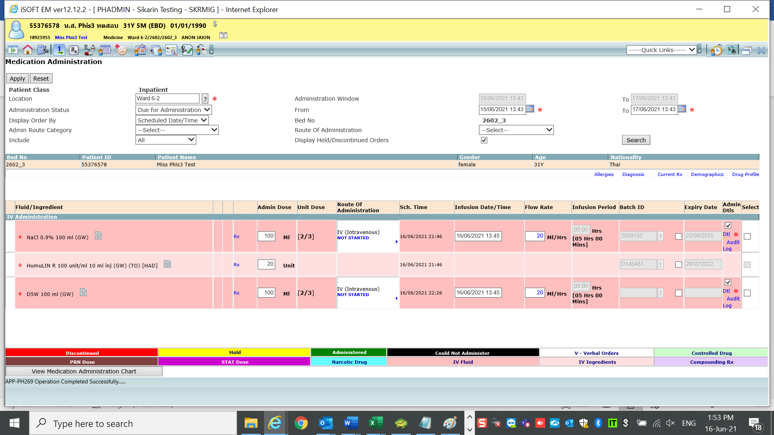

Then check report after med admin rate has been changed

1.Prescription

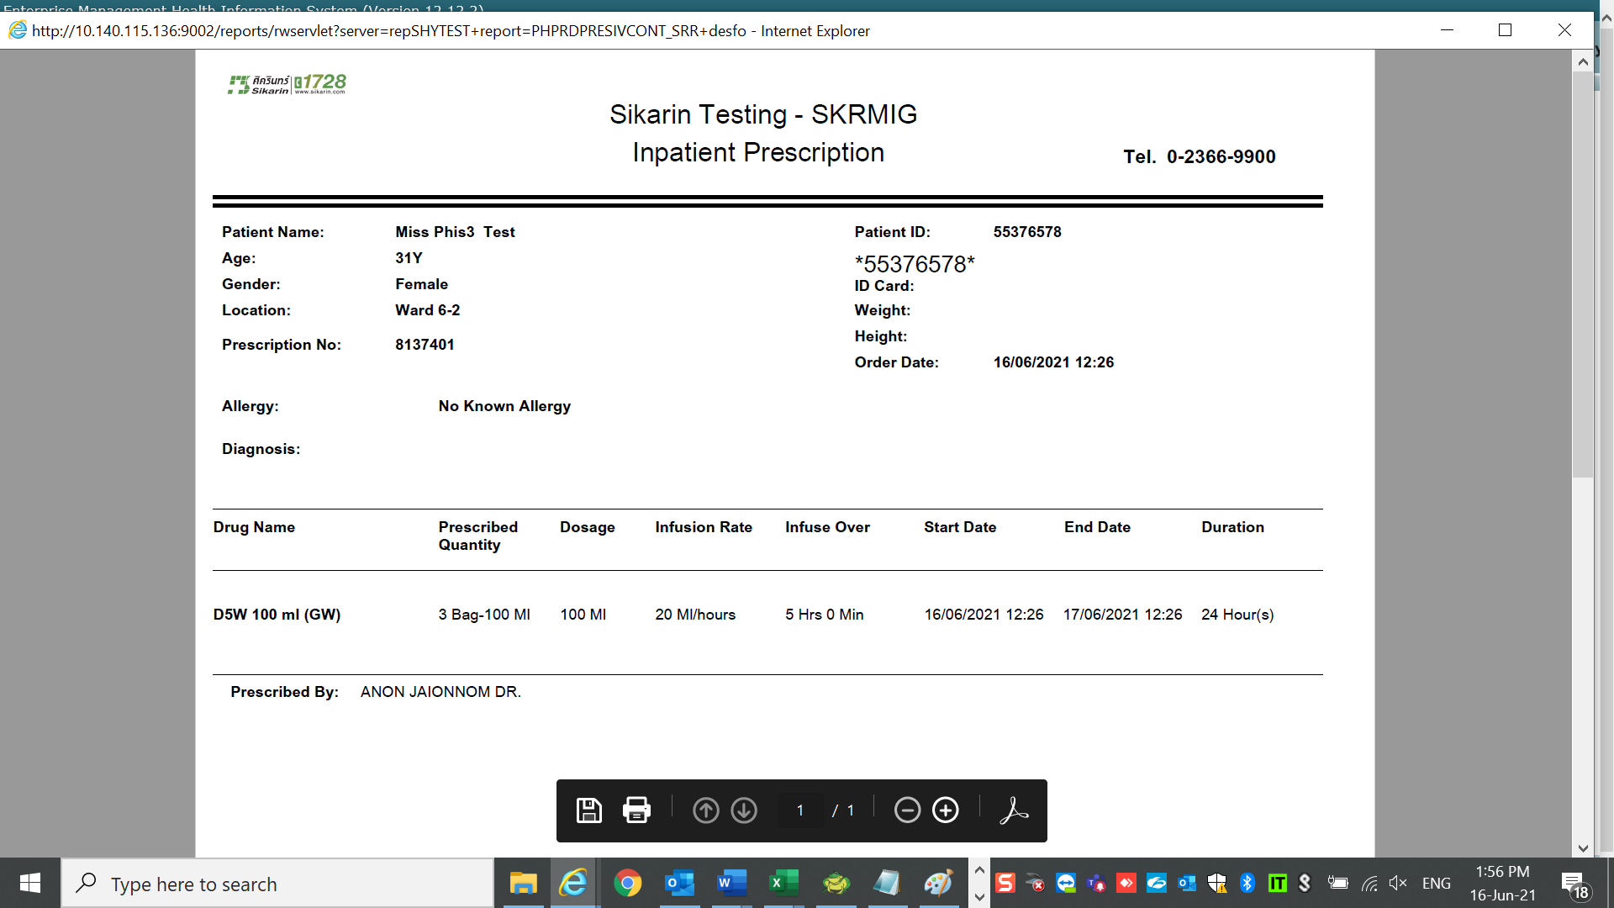

It should keep rate & infusion over

as same as original order/Amend order.

2. IV Label -Fluid label should display rate & infusion over as same as original order/Amend order

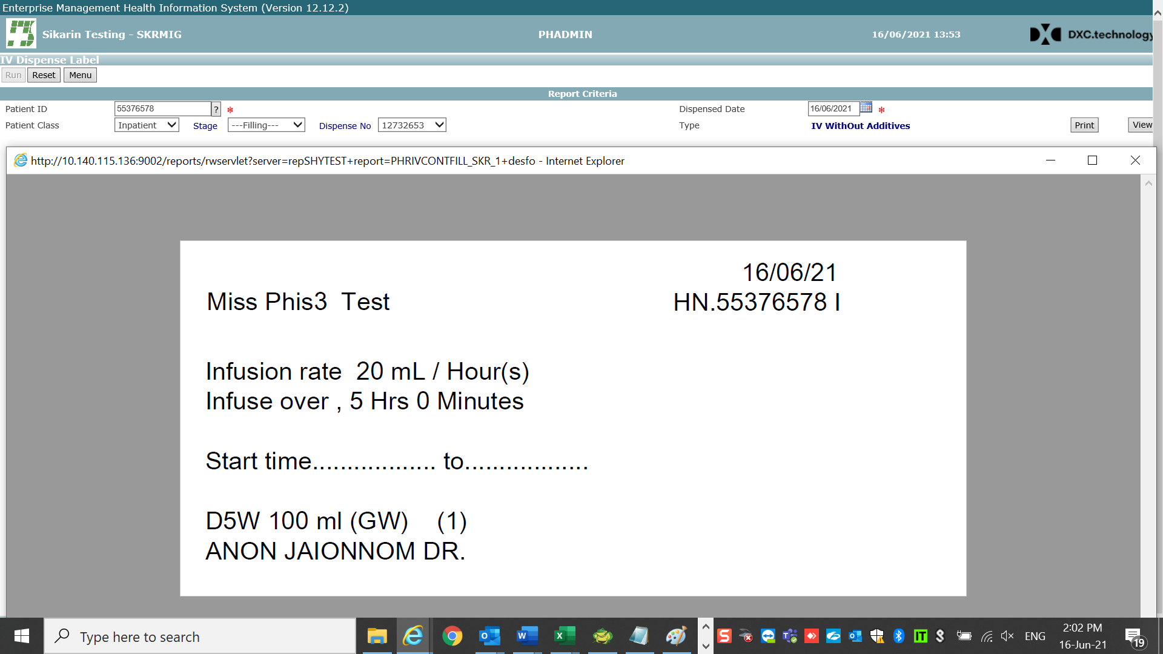

3.One day keep display flow rate base on Original/amend order correctly

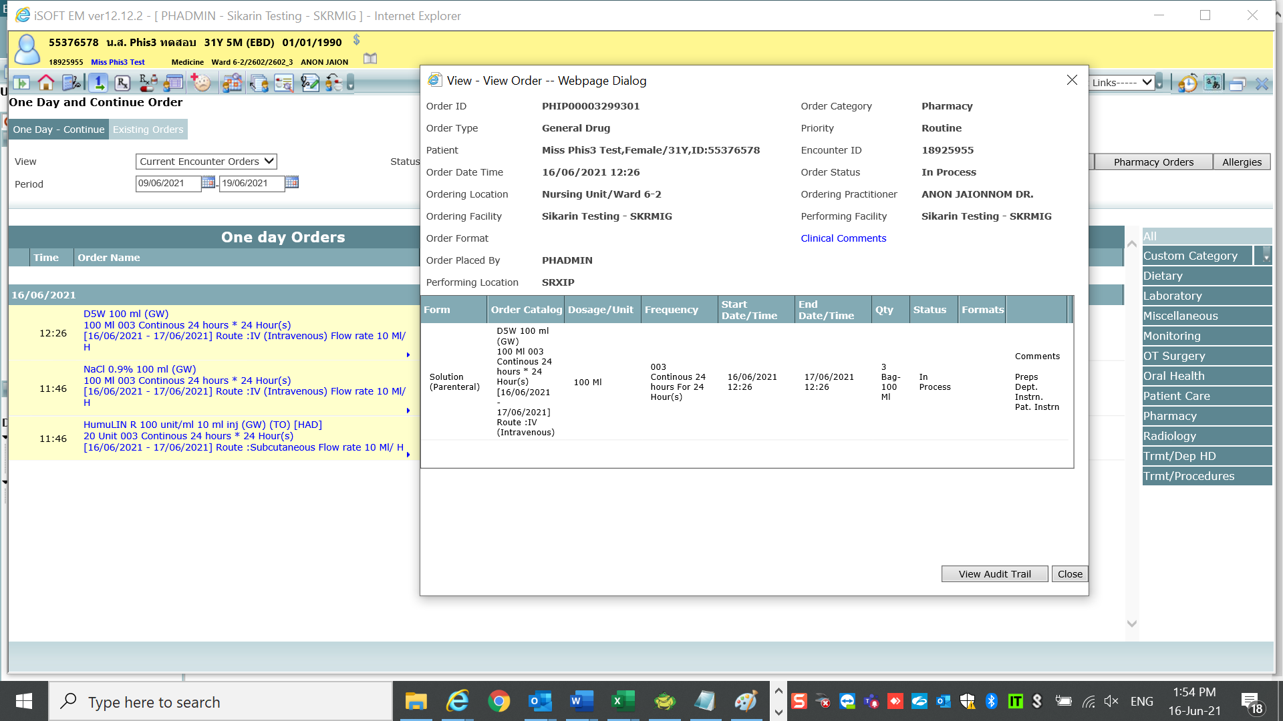

3.IV intermittent

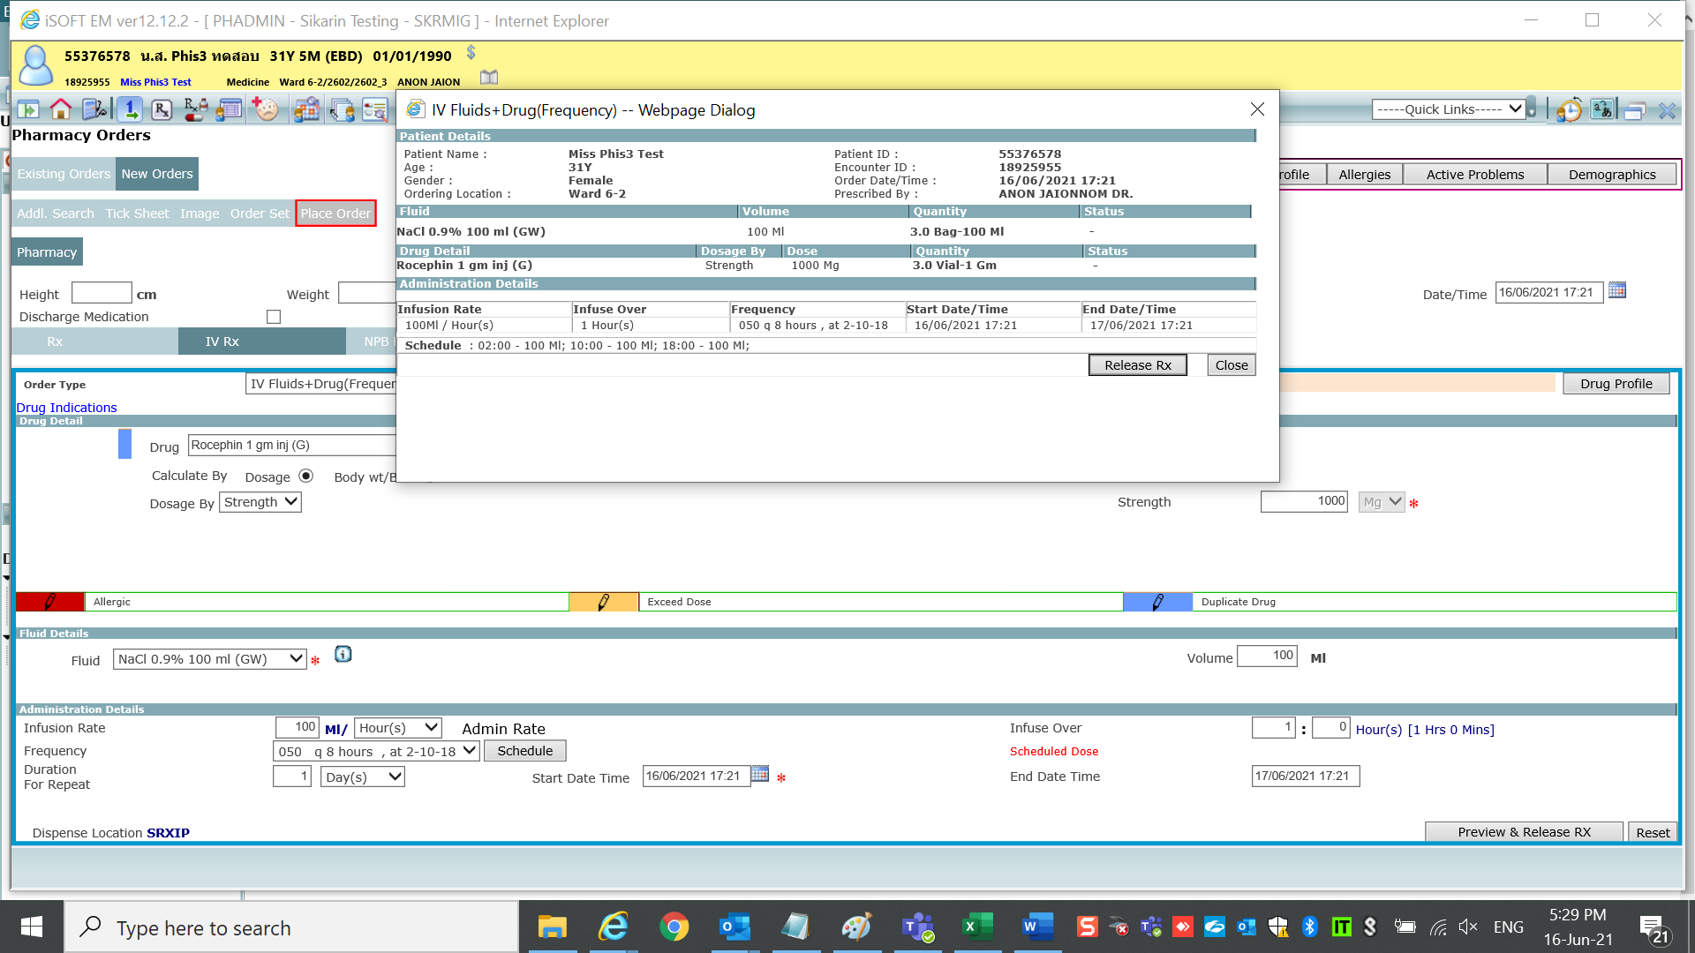

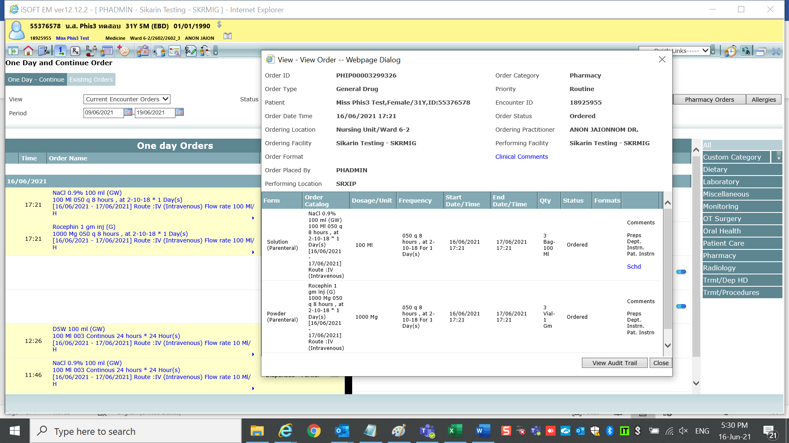

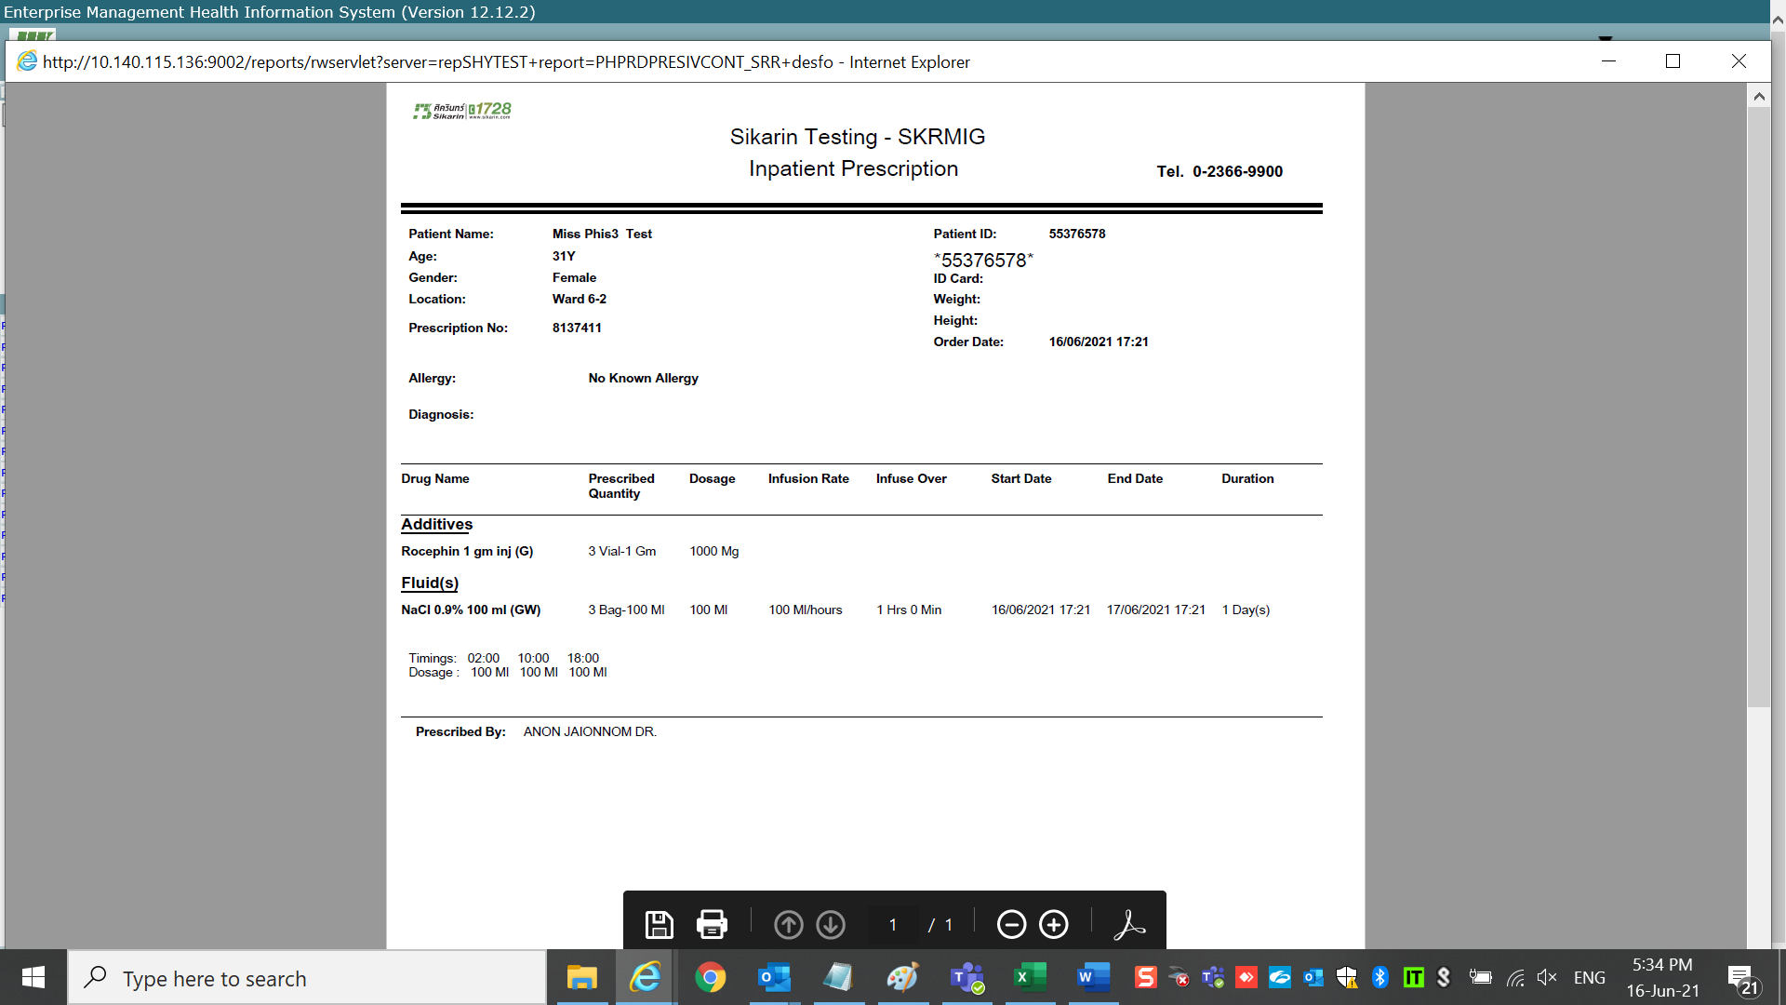

Go to med admin

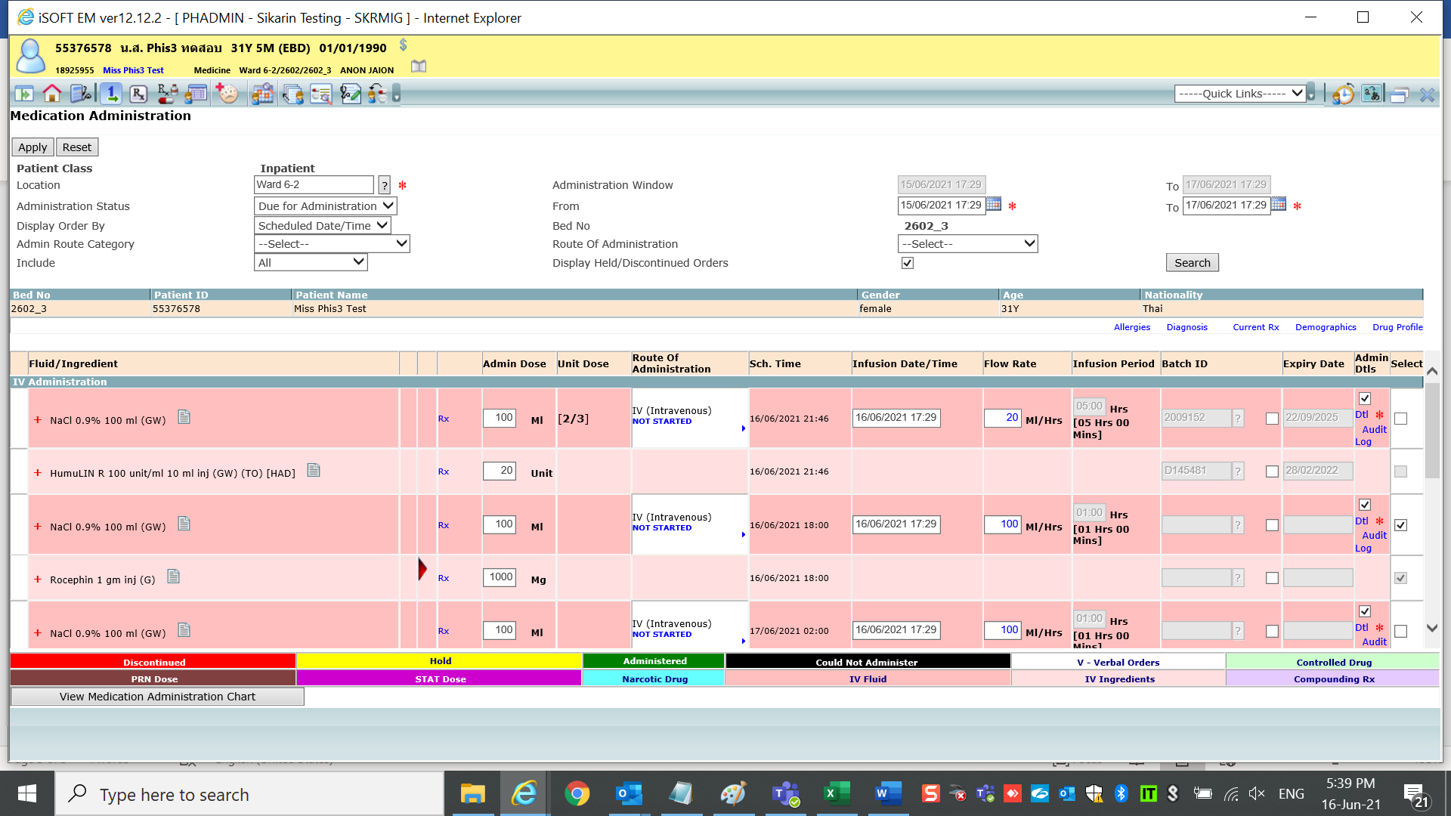

Then change rate to 50 ml/Hr

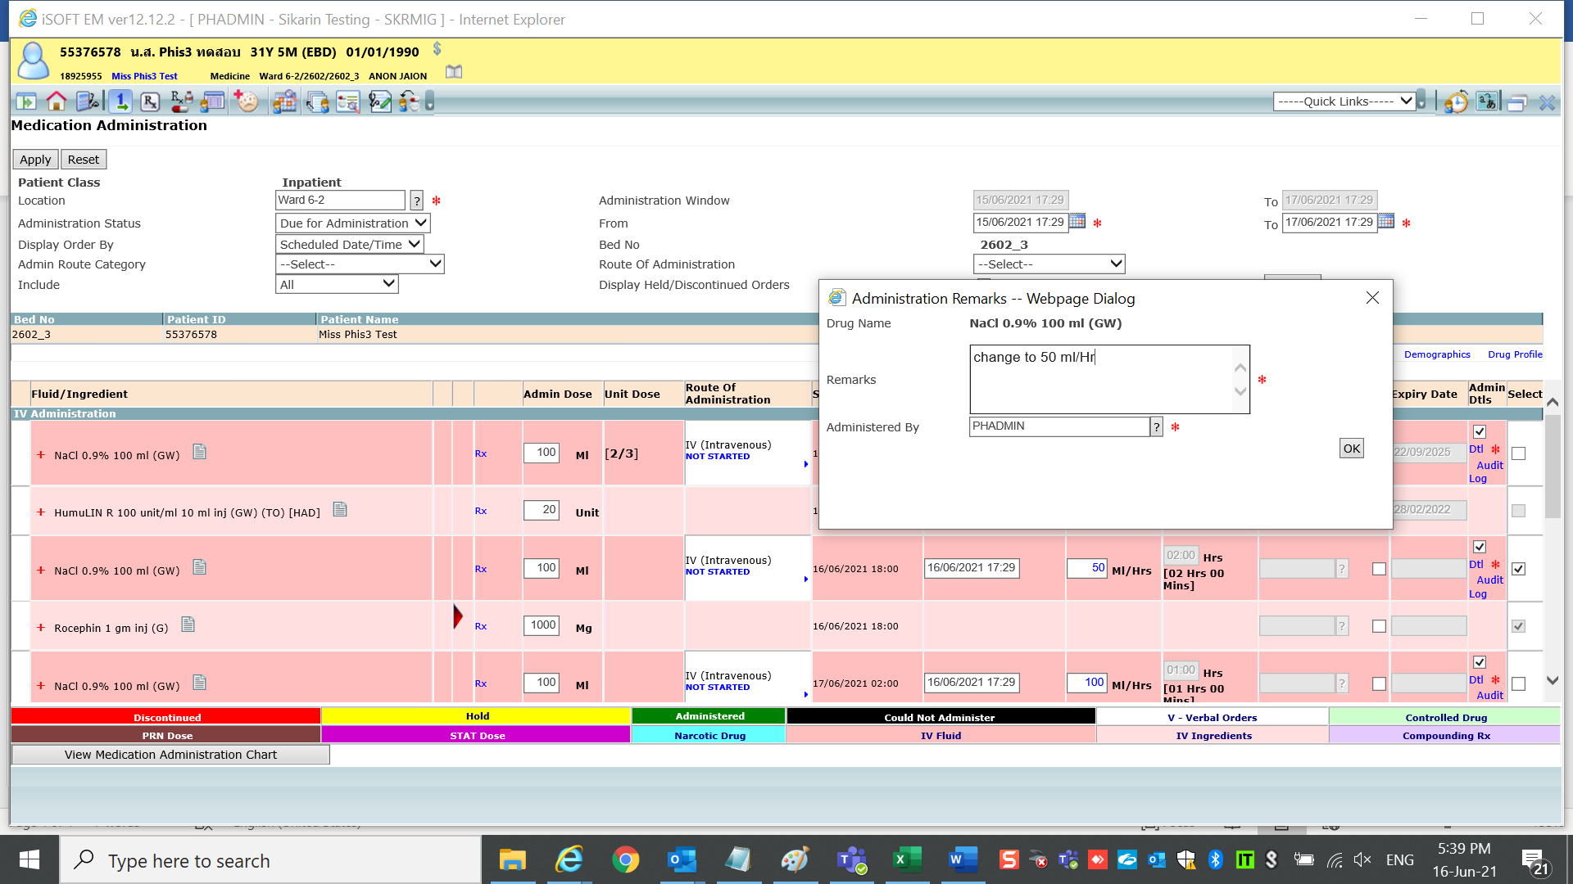

After apply

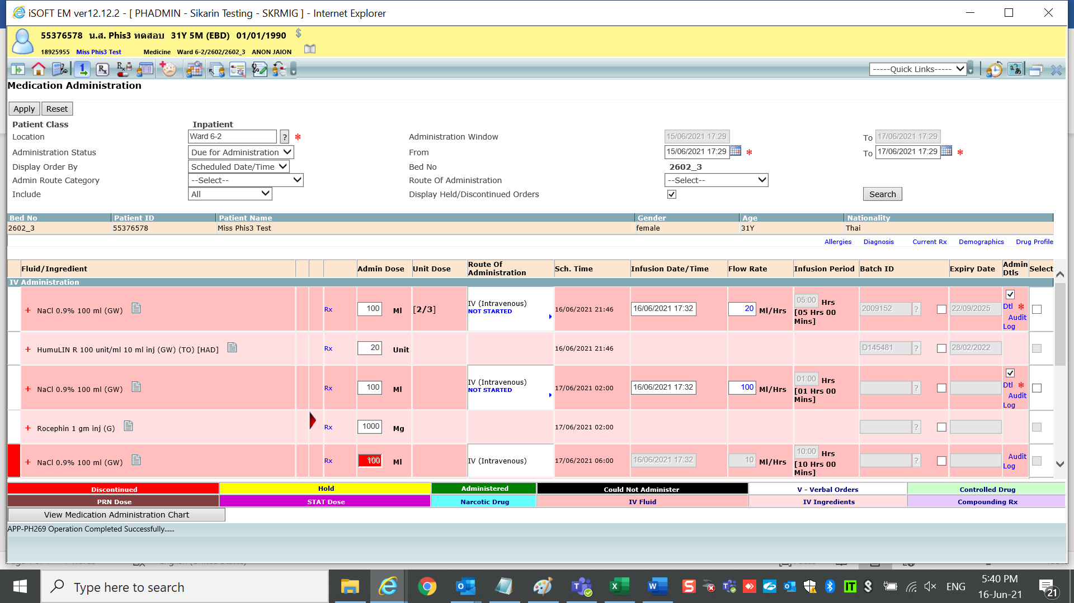

Check report after med admin change rate

1.Prescription

It should keep rate & infusion over as same as original order/Amend order.

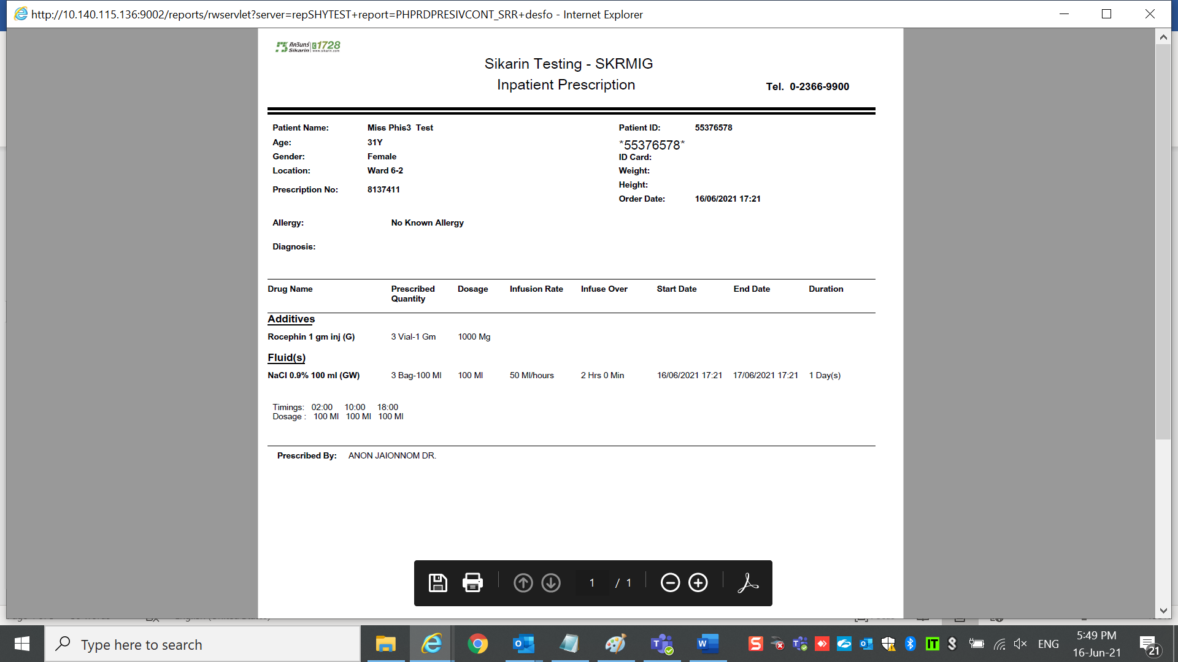

It should keep rate & infusion over

as same as original order/Amend order.

2.IV Label

Fluid label should display rate & infusion over as same as original order/Amend order

Fluid updated new rate 50ml/Hr

drug is still keep original rate 100ml/Hr correctly

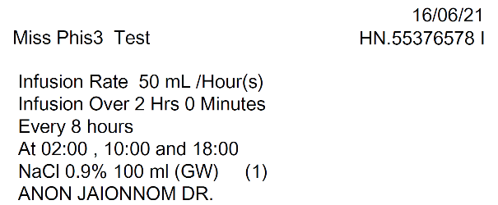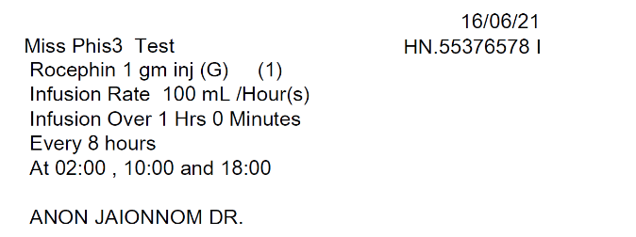

3.One day still keep flow rate from original order/Amend order correctly.

